**Vortex-Induced Vibration Research of Flat Steel Box Girder**

**With Large Wind Attack Angle**

**Yang Yang1, 2, Liangliang Zhang1, 2, Jialin Yao1, 2 and YuJia Sun1, 2**

**1**School of Civil Engineering

Chongqing University, Chongqing 400044, China

2Key Laboratory of New Technology for Construction of Cities in Mountain Area

Ministry of Education, Chongqing 400044, China

**Abstract**

Vortex-Induced Vibration(VIV) of long-span bridge is paid attention by many researchers as it occurs at low wind speed and effects the comfort of passengers. VIV is remarkable influenced by the wind attack angle, and the long-span bridge locates in the mountainous region suffers a large change of wind attack angle. Experiment of flat steel box girder is researched by wind tunnel test to study the effect of wind attack angle. Results show that both vertical and torsional VIV of flat steel box girder increase greatly at the large wind attack angle. Torsional VIV is more sensitive than vertical VIV with the large wind attack angle. When the bridge locates in the mountainous region, it is necessary to do bridge section model test at large wind attack angle.

**Introduction**

VIV often occurs at low wind speed under normal condition. Long-term VIV can lead to structural fatigue and affect driving safety. Avoiding significant level of VIV is important not only for the structure safety but also for the comfort and the safety sensation of the drivers on the bridge [1]. Wind tunnel test is a major approach in studying VIV, and hence many researchers studied the factors effecting the VIV by wind tunnel test, such as railings, guide plate, maintenance guide, spring damping ratio, wind fairing, suppression vibration plate on deck, surface roughness, wind and rain occurs at the same time on the bridge [2-8]. Guan [2] studied the railings’ effect on VIV by a bridge deck section. With the increasing of bridge’s width, separated type box beam is widely used in the long-span brige. Liu [3] and Wang [4] studied the separated bluff steel twin-box girder by sectional model wind tunnel test. Li [5] gave the effect of cantilevered walking slab on VIV. Sun [6] studied the different mitigation measures’ effect on VIV. Matteonia [7] researched the surface roughness effect on VIV. Research mentioned above were all in dry condtion, Xin [8] gave a VIV research of rain effect. Bridge locates in the mountainous region suffers a large change of wind attack angle, which has a great effect on VIV [9]. Therefore, VIV of flat steel box girderat the large wind attack angle is researched in this paper.

**Backgroud**

Main girder of Cuntan Yangtze bridge is researched in this paper. Cuntan Yangtze bridge, including main section and approach bridge, is located in Chongqing, China, with a span arrangement of 250.0m+880.0m+250.0m. Ratio of rise to span in this bridge is 1/8.8 and the distance of two main cables is 39.20m. The width and height of the girder is 42.00m and 3.50m, respectively. The middle span is a suspension structure. Width of sidewalk and medial strip is 2.00m, and the side trip is 0.50m wide. This bridge has eight-lanes and distributions of lane are shown in Figure 1.

Attachment structures in this wind tunnel test included pedestrian guardrail, anti-collision guardrail, centre separation band guardrail and lead rail.



Figure 1. Standard cross-section of main girder (cm)

Frequency and amplitude of free vibration can provide data support for bridge analysis, so it’s necessary to calculate the bridge’s dynamic properties. The whole bridge structure was modelled according to practical situation on ANSYS platform. Girder, cable bent tower and pier were scattered as beam elements, cables were modelled as member elements, and secondary permanent load was modelled as mass element. Finite element model can be seen in Figure 2. Fundamental frequencies and amplitude of free vibration can be seen in Table 1.

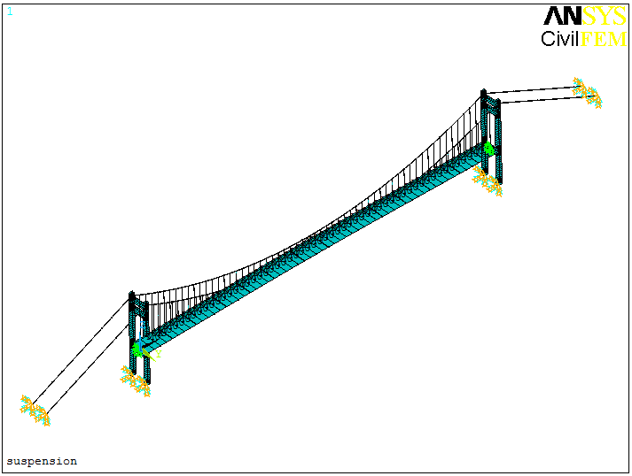

Figure 2. Finite element model of Cuntan Yangtze bridge

|  |  |
| --- | --- |
| **free vibration mode** | **self-vibration frequency (Hz)** |
| **inverse symmetric vertical vibration of first order** | 0.11625 |
| **symmetric vertical vibration of first order** | 0.17446 |
| **symmetric torsion vibration of first order** | 0.39726 |
| **inverse symmetric torsion vibration of first order** | 0.44029 |

Table 1. Natural frequencies and mode features of bridge

Allowable design value on vertical is 0.3441 m according to inverse symmetric vertical vibration of first order and 0.2293 m according to symmetric vertical vibration of first order [10]. Allowable design value on torsion is 0.2733° according to inverse symmetric torsion vibration of first order and 0.2466° according to symmetric torsion vibration of first order. Inverse symmetric vertical an torsion vibration of first order are taken as the permissible value of VIV amplitude on usual, therefore 0.3441 m on vertical and 0.2733° on torsion are taken into consideration.

Section model of the bridge was made of wood. Pedestrian guardrails, anti-collision guardrails and center separation band guardrails were manufactured in plastic plates by machine. The section model was 2.1 m in length, 0.7m in width, and 0.0583 m in height with a scalar of 1/60 to the real bridge. It was fixed by eight springs on supports, providing a vibration system with two degrees of freedom which can simulate vertical and torsional vibration. The distance of springs was 108.0 cm. Two laser displacement sensors placed under the section model were used in testing the displacement of bridge. The distance between laser displacement sensors was 40.0 cm.

Wind tunnel test requires that the section model is similar to the real bridge in geometric dimensions, as well as frequency and damping ratio. But actually the section model of bridge can’t have similarity with the prototype model in all aspects. Deviation is allowable in the wind tunnel test. Allowable damping ratio deviation should be controlled less than 10% and allowable deviation of frequency, mass should be controlled less than 3% [10]. From Table 2, it can be calculated that the deviation is 4.3% on vertical bending damping ratio and 3.8% on torsion damping ratio, and other parameters keep the same as prototype modal. As a consequence, the results of experiment are effective.

According to the scale of section modal, frequency in Table 1 and Table 2, vertical wind ratio of 4.72 and torsion wind ratio of 4.41 are calculated [10].

|  |  |  |  |  |
| --- | --- | --- | --- | --- |
| **parameter** | **unit** | **actual value** | **required value** | **value in test** |
| **height** | m | 3.5 | 0.0583 | 0.0583 |
| **width** | m | 42.0 | 0.7 | 0.7 |
| **linear mass** | kg/m | 27600 | 7.667 | 7.667 |
| **linear mass moment of inertia** | kg⋅m2/m | 5137700 | 0.3987 | 0.3987 |
| **vertical bending frequency** | Hz | 0.17446 | 2.216 | 2.216 |
| **vertical bending**  **damping ratio** | % | 0.5 | 0.389 | 0.372 |
| **torsion frequency** | Hz | 0.39726 | 5.404 | 5.404 |
| **torsion damping ratio** | % | 0.5 | 0.439 | 0.422 |

Table 2. Design parameters of VIV mode

**Wind tunnel test**

The experiments were performed in the first test section of XNJD-1 wind tunnel. This test section is 2.40 m wide and 2.00 m high. The maximum wind velocity is 45.0 m/s and the minimum wind velocity is 0.5 m/s. Both turbulence flow less than 0.1% and uniform flow can be generated by this wind tunnel. The section model was placed in the middle of the test section and it spanned all the test section width. In fact a natural wind is a turbulent flow and a boundary layer exists near the surface of the ground, the effect of the boundary layer was neglected and the experiments were performed in a uniform flow. The condition in the wind tunnel tests was more severe than the actual condition because the side force estimated on this condition was considered to be larger than that in real-life condition.

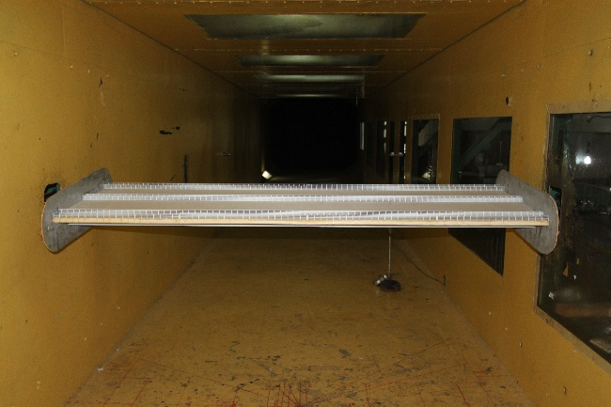

Figure 3. Response of vortex-induced vibration

In mountainous region, wind ambient is affected by topography seriously, thus wind attack angle above ±3° acts on the main bridge girder at times. Therefore, VIV wind tunnel tests between -7° to +7° wind attack angle are researched in this paper.

**Analysis of test results**

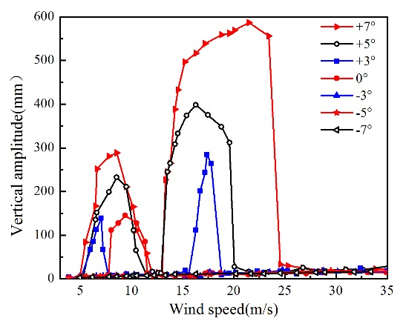

Figure 4. Vertical response of vortex-induced vibration

In the process test of VIV, two kinds of vibration were observed including vertical and torsional vibration, and the vertical vibration came firstly before torsional vibration. From Figure 4, vertical VIV was recorded at different wind speeds with each wind attack angle. Multi-lock-in regions turned up at +7°、+5°、+3° wind attack angles, and single-lock-in regions turned up at 0° wind attack angle. Multi-lock-in regions had a common characteristic that the second lock-in vertical VIV response was larger than the first lock-in region. There is no vertical VIV at -7°, -5° and -3° wind attack angles. VIV regions exist in (5.0~11.5) m/s and (13.0~25.0) m/s at +7° wind attack angle, (6.0~11.0) m/s and (13.0~18.0) m/s at +5° wind attack angle, and (5.5~7.0) m/s and (15.0~18.0) m/s at +3° wind attack angle. From the data above, it can be summarized that VIV regions reduced with decreasing of wind attack angle. The max vertical VIV value were 586.46 mm at +7° wind attack angle, 398.46 mm at +5° wind attack angle, 283.99 mm at +3° wind attack angle. Vertical VIV grew rapidly with the increasing of wind attack angle.

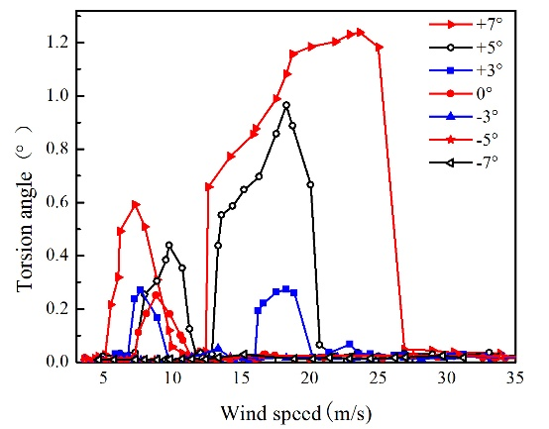

Figure 5. Torsional response of vortex-induced vibration

The max torsional VIV value were 1.296° at +7° wind attack angle, 0.964° at +5° wind attack angle, 0.273° at +3° wind attack angle. Both vertical and torsional VIV were above the allowable value at +7° and +5° wind attack angle. At +3° wind attack angle, the torsional VIV was above 0.18 percent of the allowable value, and the vertical VIV was under the allowable value. The torsional and vertical VIV were under the allowable value at 0°, -3°, -5°and -7° wind attack angle.

The section can satisfy the requirement of VIV when the wind attack angle between -3° to +3°, however the vertical and torsional VIV were above the allowable value at the large wind attack angle.

Max vertical VIV at +7° wind attack angle was above 106.51 percent at +3° wind attack angle, and max torsional VIV was 374.72 percent above the +3° wind attack angle.

Vortex-induced vibration is a resonant phenomenon caused by the periodic vortex shedding from the structures. Consequently, the vortex structure and its shedding mode play decisive roles in determining whether VIV occurs or not. In order to find the mechanism of wind attack angle effect on VIV, ANSYS 14.5 was used to simulate the vortices from 7.0 m/s to 12.0 m/s wind speed which is the range of VIV for most working conditions. It was found that wind speed at 10.0 m/s can prove the mechanism from fluid dynamic point view better than others, and hence vortices simulation at 10.0 m/s wind speed was given. Vortices value between （0-5000） s-1 were shown in Figure 6.

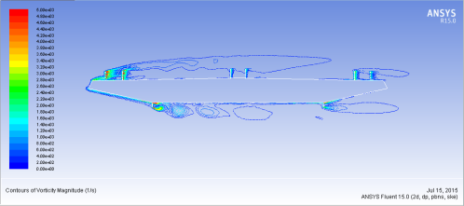

Figure 6. Vortices value without at 0° wind attack angle (s-1)

From Figure 6, it can be seen that vortices turned up around the attachment structures and the largest vortices value was concentrated on the pedestrian guardrail and lead rail on windward side. When the wind attack angle changed, the existence of aerodynamic flow around the bridge was disturbed, and had a greater influence on the bridge surface than under the bridge surface.

**Conclusions**

From the analysis of test results, it can be concluded that both vertical and torsional VIV of flat steel box girder increase greatly at the large wind attack angle. Torsional VIV is more sensitive than vertical VIV with the large wind attack angle. When the bridge locates in the mountainous region, it is necessary to do bridge section model test at large wind attack angle.

**Acknowledgments**

This work was funded by Natural Science Foundation of China (51578098, 51608074), science and technology project of Chongqing Municipal Construction Commission (20130844), and it is gratefully acknowledged.

**References**

1. Simon, P., Frederic, L., & Andre L., Effect of sway movement and motion axis on flutter and vortex induced vibration in a 3 DOF wind tunnel sectional test, *J.* *Wind Eng. Ind. Aerod.*, **136**, 2015, 82–88,.
2. Guan, Q. H., Li, J. W., Hu, Z. T., etal, Effects of railings on vortex-induced vibration of a bridge deck section, *J. Vib. Shock,* **33**, 2014, 150–156.
3. Liu, G., & Liu T. C., Sectional model wind tunnel test of a cable-stayed bridge with separated bluff steel twin-box girder, *China Civ. Eng. J.,* **43**,2010, 49–54.
4. Wang, Q., Lin, J., Liao, H.L., etal, Vortex induced vibration performance of separated type box beam bridge based on wind tunnel test, *Highway*, **7**, 2013, 294-299.
5. Li, C. G., Chen, Z. Q., & Han, Y., Vortex induced vibration performance of a streamlined box girder with a cantilevered walking slab, *J. Vib. Shock,* **33**, 2014, 19–25.
6. Sun, Y. G., Liao, H. L., & Li, M. S., Mitigation measures of vortex-induced vibration of suspension bridge based on section model test, *J.* *Southwest Jiaotong Univ,* **47**, 2014, 218-223.
7. Matteonia, G., & Georgakis, C.T., Effects of surface roughness and cross-sectional distortionon the wind-induced response of bridge cables in dry conditions, *J. Wind Eng. Ind. Aerod.*, **136**, 2015, 89-100.
8. Xin, D. B., Li H., Wang, L., etal, Experimental Study of Rain Effects on Vortex Shedding of Long Span Bridge Girders, *Adv. Struct. Eng.*, **15**, 2015, 1793–1799.
9. Zhu, S. Y., Li, Y. L., Shen J.X., etal, Optimization of vortex-induced vibration of flat steel box girders at large attack angle by wind tunnel test, *China Civ. Eng. J.,* **48**,2015, 79–86.
10. Highway planning and design institute, *Wind-resistant Design Specification for Highway Bridges*. China Communications Press, 2004.