**Measurement of the Dispersion of Spilled Heavy Gas between a Trapezoidal Hill and a Building**

**B.S. Shiau1, C.Y. Wang1 and R.R. Hwang2**

**1**Department of Harbor and River Engineering

National Taiwan Ocean University, Keelung 20224, Taiwan

2Department of Systems Engineering and Naval Architecture

National Taiwan Ocean University, Keelung 20224, Taiwan

**Abstract**

Wind tunnel experiments were conducted to investigate the dispersion characteristics of continuously spilled heavy gas between a trapezoidal hill and a building. The spill source was located at the hill top surface center. A trapezoidal hill is with equal upwind and downwind slopes. Slope angles of 15° and 30° were run in the experiments. A building is located at downstream of the hill, and its height is one and half times and two times of the hill height. The distance between a hill and a building was one time and three times of hill height. Effects of the hill slope angles, the building heights, and the distance between a hill and a building on the heavy gas cloud dispersion, and dispersion parameters were investigated.

**Introduction**

Chemical plants located at the hill top were often existed in Taiwan, and in the downstream of the hill there have residential buildings. The plants have many kinds of chemical gases storage tanks. The chemical gases are almost toxic and they are heavier than the air. These kinds of gases are usually called heavy gases or dense gases. Accident of continuous spill of heavy gas from the storage tanks is dangerous event, and it has a strong impact on the near-by residential living environment.

Britter [1] had made a review on the dispersion of dense gas in the atmosphere. Ramsay [7] studied the topography effect on the heavy gas dispersion. Schatzmann [10, 11] indicated that the dispersion of the heavy gas is quite different from that of the airborne pollutants. Robin et al. [8] conducted the wind tunnel study on the dense gas dispersion in a neutral boundary layer over a rough surface. Hanna et al [3] measured on the depression and downwind concentrations for the Chlorine instantaneous release of field experiments. Scargiali et al. [9] used the computational fluid mechanics model to simulate the dense gas cloud in urban areas. Meroney [5] used the CFD model to simulate dense gas cloud dispersion over irregular terrain. Mokhtarzadeh-Dehghan et al. [6] studied the heavy gas dispersion in the neutral atmospheric boundary layer by numerical and experimental methods.

The hill slope angles, the building height and the distance between a hill and a building are important parameters for assessing heavy gas cloud pollution impacts on the building environment. In the present study, wind tunnel experiments were performed to measure the heavy gas cloud dispersion under different hill downwind slope angles, building heights and various distances between the hill and the building.

**Experimental set-up**

The experiments were carried out in the National Taiwan Ocean University’s Environmental Wind Tunnel. The wind tunnel test section is 12.5 m long and has a cross section of 2 m wide by 1.4 m high. The tunnel is an open suction type and it contracts to the test section with an area ratio of 4:1. The turbulence intensity of empty tunnel in test section is less than 0.5 % at the mean velocity of 5 m/s.

An X-type hot-wire incorporating with the TSI IFA-300 constant temperature anemometer was employed to measure the turbulent flow signals. Output of the analog signals for turbulent flow was digitized at a rate of 4 k Hz each channel through the 12 bit Analog-to–Digital converter. Since none of the analog signals containing significant energy or noise above 1 k Hz, with the Nyquist criteria, a digitizing rate of 2 k Hz was sufficient. The low pass frequency for the analog signals was chosen as 1 k Hz in all runs of the experiments.

Carbon dioxide (CO2) is used as tracer of heavy gas, which had the molecular weight of 44 (1.52 times molecular weight of air). Dispersion experiments were executed by continuously spill the carbon dioxide (CO2) of heavy gas at a controlled flow rate from a point source. Sampling tracer of the heavy gas was carried out for various spilling flow rates at different downstream stations. For concentration measurements, tracer gas sampling system was developed. It is composed of 15 sampling tubes that arranged in a rake. The 15 tubes attached to 15 air bags and suck the tracer gas by pumps. In order to obtain sufficient tracer concentration analysis, 5 minutes of sampling time was executed in every downstream station. Mean concentrations of the sampled tracer gas in air bags were obtained by the Cole-Parmer carbon dioxide detector. The detector can analyse the CO2 concentration within the range of 0~100000 ppm with a resolution of 10 ppm.

Figure 1 showed the arrangement of the experiments for the hill and the building models. The spill source was located at the hill top surface. The hill height is H; The building height is Hb; The distance between the hill and the building is W; The hill slope angle is θ. The hill model height H is adopted as the characteristics length in the dimensionless parameters analysis.

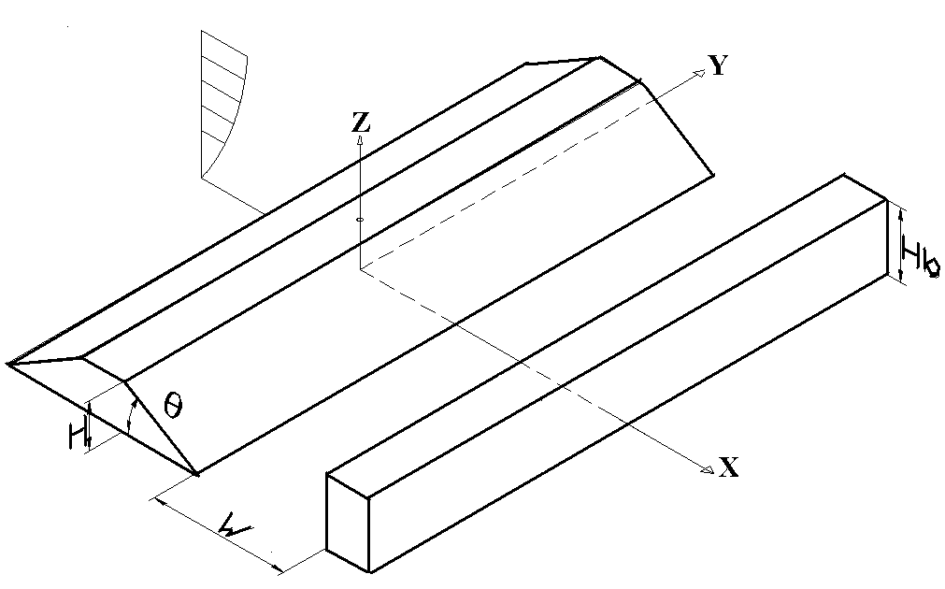

Figure 1. Schematic diagram of the experimental models arrangement and measurement coordinate system.

**Results**

*Approaching Flow*

Four spires of 100 cm height and cubic elements (5 cm x 5 cm x 5cm) are properly arranged as the roughness at the entrance of test section to generate a thick turbulent boundary layer which is used as the approaching flow. A neutral atmospheric boundary layer flow was simulated as the approaching flow. Figure 2 shows the simulated mean wind velocity profile of approaching flow. The turbulent boundary layer flow mean velocity profile is expressed in power law form as follows:

 (1)

where *U* is the mean velocity at the height of *Z*, *Uref*is the free stream velocity, *Zref* is the boundary layer thickness. In the present study, the power law with an exponent *n*=0.27, was simulated as the approaching flow. This value lies in the range of 0.23 to 0.40 as proposed by Counihan [2] for neural atmospheric turbulent boundary layer flow in the urban region. The longitudinal turbulence intensity profile of approaching flow is shown as Figure. 3. The longitudinal turbulence intensity I(u) is defined as the ratio of root mean square of flow velocity fluctuation and the local mean flow speed. The turbulence intensity close to the ground is roughly greater than 20%. Counihan [2] had indicated that the longitudinal turbulence intensity near the wall for urban region fell in the range of 20% to 35 %. The turbulent velocity power spectrum of the simulated approaching flow is shown in Figure 4 which is found to agree with the Von Karman spectrum equation and Eurocode wind spectrum equation.

描述: power-law profile

Figure 2. Mean velocity profile of approaching flow.

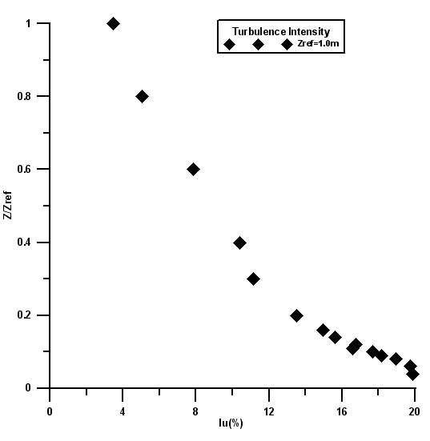

Figure 3. Longitudinal turbulence intensity profile of approaching flow.

*Validation of Experimental Measurement*

To verify the present experimental measurement of the heavy gas plume, the settling down position of the plume was compared with the calculation of semi-empirical formula proposed by Meroney [4]. Figure 5 is the schematic diagram of heavy gas cloud settlement. And the semi-empirical formula for calculation of settling down position is shown as follows:



 (2)

where .

Figure 6 is the comparison of present measurement results of the plume settlement position and the semi-empirical prediction results. The figure shows that the results of present experimental measurements for various Fr and spilled heights h are quite close to that of obtained from the semi-empirical formula predictions.

描述: 能譜

Figure 4. Comparison of the measured longitudinal turbulent velocity power spectrum with Von Karman and Eurocode wind spectrum equations at height Z/Zref=0.1.

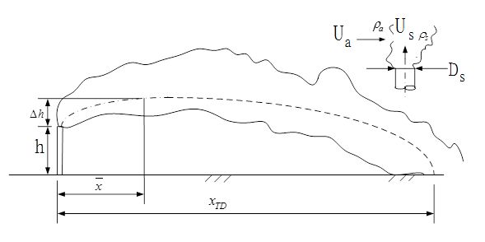

Figure 5. Schematic diagram of heavy gas cloud settlement.

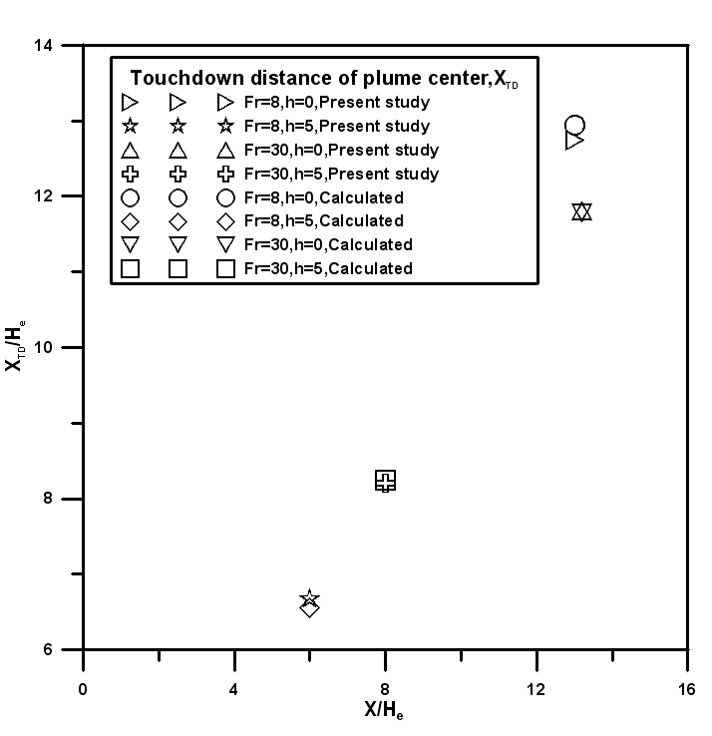

Figure 6. Comparisons of touchdown distance of plume between the present measurements and the predictions of semi-empirical equation.

*Concentration Distribution*

The experimental measurements on concentration distributions for different hill slope angles, building heights, and various distances between hill and building were performed. The measured concentration  is scaled in dimensionless form.

 (3)

where  is the measured concentration in ppm;  is the effective height of heavy gas cloud in m;  is the cross wind velocity in m/s;  is spill discharge rate in m3/s.

Figure 7 shows the horizontal concentration distribution at the height Z/H=0.5 for a hill with slope angle of θ=15°, building height Hb=2H, and distance between a hill and a building W=H. Results indicate that heavy gas cloud accumulated around the front region of building. Since the building blocked the heavy gas cloud, they spread laterally along the front face of building.

Figure 8 is the vertical concentration distribution along the heavy gas cloud centerline for a hill with slope angle of θ=15°, building height Hb=2H, and distance between a hill and a building W=H. The concentration contours reveal that the heavy gas cloud spread along the hill slope surface and blocked by the building. The cloud accumulated around the region between a hill and a building.

The variation of ground concentration along the downstream distance of source for a hill with slope angle of θ=15° with various building heights and distances between a hill and a building are shown in Figure 9. Either the distance between a hill and a building is shorter W=H or longer W=3H, the ground concentration decreased along the downstream distance of source. The ground concentration around the region between the hill toe and the building becomes larger as the distance between a hill and a building was shorter for the building height Hb=1.5H. But as the building height increased from Hb=1.5H to Hb=2H, the ground concentration around the region between the hill toe and the building became smaller when the distance between a hill and a building was shorter.

描述: 15(W=1H Hb=2H)0

Figure 7. The horizontal concentration contours at the height Z/H=0.5 for a hill with slope angle of θ=15°, the building height Hb=2H, and distance between a hill and a building W=H.

15(W=1H Hb=2h)

Figure 8. The vertical concentration contours along the heavy gas cloud centerline for a hill with slope angle of θ=15°, the building height Hb=2H, and the distance between a hill and a building W=H.

Figure 10 shows the vertical concentration profiles at the location of center between a hill toe and a building for different building heights and various distances between a hill and a building as θ=30°. Due to the building blockage effect, it is found that the maximum concentration occurred at higher position when building height increased. The vertical concentration profiles at the location of center between a hill toe and a building for different building heights and hill slope angles as W=3H was shown in Figure 11. It is found that when the hill slope angle increased form 15° to 30°, the concentration increased due to the flow recirculation induced by the hill topography with a larger slope angle of 30°.

描述: 15

Figure 9. The variation of ground concentration along the downstream distance of source.

描述: 30

Figure 10. The vertical concentration profiles at the location of center between a hill toe and a building for different building heights and various distances between a hill and a building; θ=30°.

描述: W=3H 

Figure 11. The vertical concentration profiles at the location of center between a hill toe and a building for different building heights and hill slope angles; W=3H.

*Dispersion Parameter Analysis*

The heavy gas cloud dispersion parameters *σy* designate as the standard deviation of the concentration distributions in horizontal direction. The parameter represents the extents of spread for the cloud in horizontal direction. Applying the concentration distribution, the dispersion parameters *σy* is computed as follows:

 (4)

where *C* is the measured tracer concentration; y is the horizontal ordinates of Cartesian coordinates. *yc* is the location of centroid for horizontal concentration distributions.

 (5)

描述: 15(0

Figure 12. The horizontal dispersion parameter as the functions of the downstream distance for various building heights and different distances between a hill and a building; θ=15°, Z/H=0.5.

描述: 30(0

Figure 13. The horizontal dispersion parameter as the functions of the downstream distance for various building heights and different distances between a hill and a building; θ=30°, Z/H=0.5.

The horizontal dispersion parameter as the functions of the downstream distance for various building heights and different distances between a hill and a building when the hill slope angle being θ=15° and at the height of Z/H=0.5 are shown in Figure 12. The figure shows that the horizontal dispersion parameter increased as the downstream distance increased. At the locations of hill downwind slope (X/H=3) and center (X/H=4.5) of a hill toe and a building, the horizontal dispersion parameter decreased when the distance between hill and building changed from W=H to W=3H, either the building height is Hb=1.5H or Hb=2H.

Figure 13 is the horizontal dispersion parameter as the functions of the downstream distance for various building heights and different distances between a hill and a building when the hill slope angle being θ=30° and at the height of Z/H=0.5. It is shown that horizontal dispersion parameter increased along the downstream distance. At the location of X/H=2.5 which was between a hill toe and a building, the horizontal dispersion parameter increased when the building height increased from Hb=2H to Hb=1.5H.

**Conclusions**

Wind tunnel measurement results are summarized as: (1) Measurement of the heavy gas cloud settle down position was found to close to the predicted results of formula proposed by Meroney [4]. (2) The concentration contours reveal that the heavy gas cloud spread along the hill slope surface and blocked by the building. Then the cloud accumulated around the region between a hill and a building. Either the distance between a hill and a building was shorter W=H or longer W=3H, the ground concentration decreased along the downstream distance of source. (3) At the location of center between a hill toe and a building, as the hill slope increased form 15° to 30°, the concentration increased due to the flow recirculation induced by hill topography with larger slope angle of 30°. (4) At the height of Z/H=0.5, the horizontal dispersion parameter increased along the downstream distance either for a hill with slope angle of 15° or 30°.

**References**

1. Britter, R.E., Atmospheric Dispersion of Dense Gases, *Ann. Rev. of Fluid Mecha.*, **21**, 1989, 317-44.
2. Counihan, J., Adiabatic Atmospheric Boundary Layers: A Review and Analysis of the Data from the Period 1880-1972, *Atmo. Environ.*, **9**, 1975, 871-905.
3. Hanna, S.R., Britter, R., Argentac, E., Chang, J., The Jack Rabbit Chlorine Release Experiments: Implications of Dense Gas Removal from a Depression and Downwind Concentrations, *J. Hazard. Materials*, **213-214**, 2012, 406-412.
4. Meroney, R. N., Wind-Tunnel Experiments on Dense Gas Dispersion, *J. Hazard. Materials*, **6** ,1982, pp.85-106.
5. Meroney, R.N., CFD Modeling of Dense Gas Cloud Dispersion over Irregular Terrain, *J. Wind Engn. and Indus. Aerodyn*., **104–106**, 2012, 500–508.
6. Mokhtarzadeh-Dehghan, M.R., Akcayoglu, A., Robins, A.G., Numerical Study and Comparison with Experiment of Dispersion of a Heavier-than-air Gas in a Simulated Neutral Atmospheric Boundary Layer, *J. Wind Engn. and Indus. Aerodyn.*, **110**, 2012, 10-24.
7. Ramsay, S. R., Dense Gas Dispersion in Complex Setting: Part 2-The Effect of Topography, *Wind Climate in Cities*, 1995, 607-629.
8. Robins, A., Castro, I., Hayden, P., Steggel, N., Contini, D., and Heist, D., A Wind Tunnel Study of Dense Gas Dispersionin a Neutral Boundary Layer over a Rough Surface, *Atmo. Environ.*, **35**, 2001, 2243-2252.
9. Scargiali, F., Grisafi, F., Busciglio, A., Brucato, A., Modeling and Simulation of Dense Cloud in Urban Areas by Means of Computational Fluid Mechanics, *J. Hazard. Materials*, **197**, 2011, 285-293.
10. Schatzmann, M., Experiments with Heavy Gas Jets in Laminar and Turbulent Cross-Flows, *Atmo. Environ.*, **27A**, 1993, 1105-1116.
11. Schatzmann, M., *Accidental Release of Heavy Gases in Urban Areas*, Wind Climate in Cities*,* Cermak, J.E., et al. (Eds.), 1995, 555-574.