Effects of Surface Roughness on Wake-induced Vibrations of Two Parallel Cables

X.Q. Du^{1, 2}, Y. Zhao¹, S.R. Chen³, Daichin^{2, 4}, B.J. Jiang¹
¹Department of Civil Engineering
Shanghai University, Shanghai 200444, China
²Wind Engineering and Aerodynamic Flow Control Research Center
Shanghai University, Shanghai 200444, China
³Department of Civil and Environmental Engineering
Colorado State University, Fort Collins, CO 80523, United States
⁴Shanghai Institute of Applied Mathematics and Mechanics
Shanghai University, Shanghai 200072, China

Abstract
The effects of surface roughness on wake-induced vibrations of two circular cylinders are investigated at Reynolds numbers of 18,000~168,800. Two types of wake-induced instability phenomena with completely distinct dynamic responses are identified on two cylinders both with smooth surface. As for two cylinders both with rough surface, the downstream cylinder oscillates in a limited range of velocity, showing “velocity-restrained vibrations” rather than divergent ones. The reasons for the significant changes of dynamic characteristics of the WIV may lie in the Reynolds number effects.

Introduction
Cables of long-span cable-supported bridges are prone to various wind-induced vibrations due to their inherent characteristics of flexibility, low damping and small mass. When two or more cables are arranged close to each other, the downstream cable is susceptible to wake-induced vibration (WIV) under the wake interference of the upstream cable. Large-amplitude WIVs of parallel cables have been observed on both cable-stayed bridges and suspension bridges [2,7,10]. The occurrence possibility of WIV increases as the span of cable-supported bridge gets longer and the cable gets more flexible.
As pointed out by Fujino and Siringoringo [4], there exist three categories of WIV with different mechanisms, i.e. wake-induced vortex vibration (WIVV), wake galloping (WG) and wake-induced flutter (WIF). WG and WIF are two types of aeroelastic instability phenomena with large amplitudes. WG oscillates mainly in the across-wind direction, while WIF vibrates in both along-wind and across-wind directions and characterizes an elliptical trajectory with the dominant axis inclined from the wind axis. It is commonly regarded that WG happens when two circular cylinders are arranged relatively close to each other at the spacing ratio of P/D=1.5~6 (P is the pitch spacing between two circular cylinders, D is the diameter of the cylinder), while WIF occurs when P/D = 8~20. However, recent studies have found than the WIF may happen at the spacing ratio of P/D<8 [9].
Furthermore, it is well known that aerodynamics of and flow field around two static circular cylinders are particularly sensitive to the Reynolds number [6]. It also has been reported that Reynolds number has an important role in both WG [8] and WIF [3]. However, most of the previous studies were conducted at relatively low subcritical Reynolds numbers. In addition, surface roughness of the cylinder has important effects on the aerodynamics and flow-field characteristics of circular cylinders. Lifting surface roughness of a circular cylinder can make it enter the critical Reynolds number regime and the supercritical regime at low Reynolds numbers. However, very limited study addressed the effect of surface roughness on WIV of two circular cylinders.
The present study aims to investigate experimentally the effects of surface roughness on wake-induced vibrations of two closely arranged circular cylinders with P/D=4 and α=0°~20° at Reynolds numbers of 18,000~168,800. The upstream circular cylinder is stationary, while the downstream cylinder is supported by springs and could move in two degrees of freedom. Two types of circular cylinder with different surface roughness are adopted. The responses of wake-induced instabilities for various attack angles are obtained and two types of instability phenomena with distinct dynamic response characteristics are identified. The effects of surface roughness on dynamic responses of the two instabilities, such as maximum amplitude, time history of response and oscillation trajectory, are investigated. Reynolds number effects on the instabilities are discussed as well.
Wind Tunnel Tests
In order to acquire relatively high Reynolds numbers, two rigid sectional circular cylinders with the same diameter of D=180mm are used in the tests. Figure 1 shows the schematic diagram of the experimental model. The upstream cylinder is fixed on the set-up, which can be adjusted to acquire five attack angles of 0°, 5°, 10°, 15° and 20°. The downstream cylinder is supported by four springs at each end and can vibrate in both along-wind and across-wind directions with an almost identical frequency of f=1.73Hz. The centre-to-centre spacing of the two cylinders is four times of the diameter, i.e. P/D=4. The experimental Reynolds numbers based on the diameter of one single cylinder and the incoming wind velocity range from Re=18000 to 168800.
Two types of circular cylinder with smooth surface and rough one are adopted as shown in Figure 2. Both of the two cylinders are made from acrylic tubes. The surface of the smooth cylinder is left unprocessed, while the surface of the rough cylinder is wrapped with sandpapers to increase the surface roughness. The relative roughness of the rough cylinder is around k_{s}/D=0.37% (k_{s} is the equivalent hydrodynamic roughness height as defined by Achenbach [1].
Four combinations of the two types of cylinder are tested, that is two cylinders both with smooth surface (SS), rough upstream cylinder and smooth downstream one (RS), smooth upstream cylinder and rough downstream one (RS), two cylinders both with rough surface (RR). Other experimental parameters of the test are listed in Table 1.
The tests were conducted in the wind tunnel laboratory at Shanghai University, which has a working section of 1.8m width, 1.2m height and 18m length. At the end of downstream cylinder, accelerometers are deployed to measure the along-wind and across-wind movements of the cylinder.

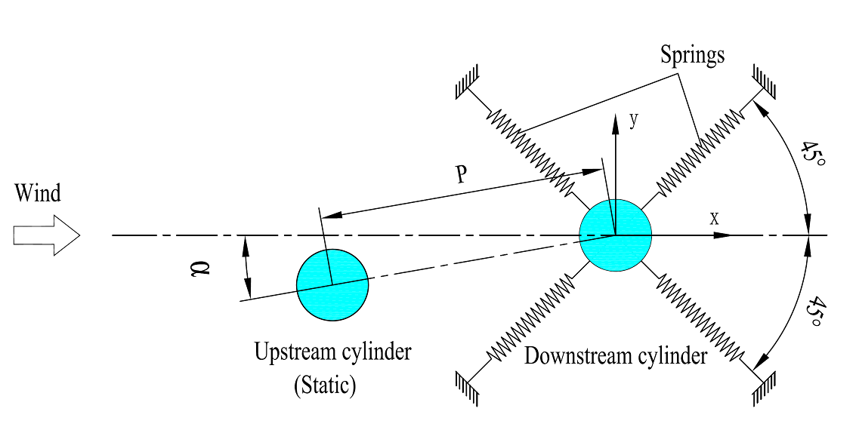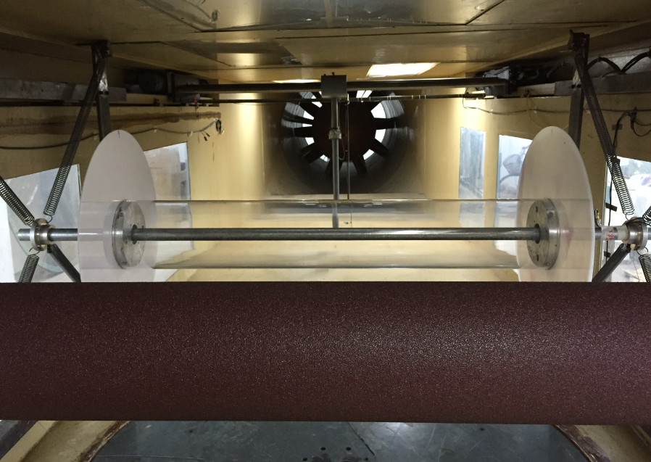
Figure 1 Schematic diagram of the cable models. Figure 2 Cable models with rough upstream one and smooth downstream one.

Diameter of the cylinders, D (mm) | 180
Weight of the downstream cylinder, m (kg/m) | 12.6 (smooth cylinder), 13.2(rough cylinder)
Degrees of freedom | 2 (along-wind and across-wind)
Frequency, f (Hz) | 1.73
Attack angle, α | 0°, 5°, 10°, 15°, 20°
Logarithmic damping decrement, δ | 0.007 (smooth cylinder), 0.010（rough cylinder）
Scruton number, Sc* | 5 (smooth cylinder), 7 (rough cylinder)
Reynolds number, Re | 18000 - 168800
*: Scruton number is defined as Sc=2mδ/ρD2, where ρ is the air density.
Table 1 Parameters of the wind tunnel test

Results and Discussion
Two Cylinders both with smooth surface (SS)
Figure 3 presents the maximum amplitude of WIV against the reduced velocity and Reynolds number for the two circular cylinders both with smooth surface when α=5º, 10º and 15º. Figure 4 illustrates oscillation trajectories of the downstream cylinder at typical reduced velocities for various attack angles. Two dimensionless parameters, X/D and Y/D, are introduced to denote the maximum amplitudes of along-wind and across-wind movements respectively.
As shown in the Figure 3, the downstream cylinder experiences wake-induced vortex vibration in synchronization range with the reduced velocity (V/fD) around 6. As the reduced velocity increases further, large amplitude wake-induced instabilities happen. For α=5º (Figure 3a), the downstream cylinder shows a divergent-type oscillation at the reduced velocity beyond the synchronization. The across-wind amplitudes are much higher than those of along-wind ones. The cylinder begins to oscillate at a reduced velocity around 8 and the vibration amplitude increases quickly to a level higher than 1D with the growing of the reduced velocity. At the reduced velocity of 35, the amplitude reaches the allowable limits that can be accommodated by the test facility. With the attack angle increasing to α=10º, as shown in Figure 3b, the dynamic characteristics of the downstream cylinder show small changes as compared to those of the case of α=5º. The onset reduced velocity of the vibration decreases slightly and the cylinder begins to suffer from large amplitude vibration at a reduced velocity as low as 8. The across-wind amplitudes reduce slightly and the along-wind ones increase a little. In general, the large dynamic responses for the cases of α=5º and 10º are similar and occur mainly in the transverse direction as shown in Figure 4a and Figure 4b, which is a typical dynamic characteristic of wake galloping. When the attack angle increases further to α=15º, the vibration characteristics change significantly, as observed in Figure 3c. The instability occurs at the reduced velocity around 8 and the vibration characteristics are similar to those of α=10º, with the transvers response much larger than longitudinal one. Nevertheless, after the instability occurs, the amplitudes of the vibration have not kept growing with the increase of the reduced velocity as expected. The amplitude of across-wind vibration falls suddenly to the level of along-wind vibration when the reduced velocity reaches 20. Accordingly, the trajectories of the vibration also change dramatically when the reduced velocity increases as shown in Figure 4c and Figure 4d. For the low reduce velocity, V/fD=16, the downstream cylinder oscillates in nearly vertical direction. While for the high ones, V/fD=29, the cylinder vibrates both in vertical and transverse directions. This kind of response characteristics of instability are different from that of the classic galloping, whose amplitude grows with the velocity once the galloping happens at a critical velocity and finally reaches a limit cycle. The phenomenon indicates that there exist two types of wake-induced instability phenomena with different mechanisms.

(a)(b)(c)
Figure 3 Maximum amplitude of WIV for the SS combination. (a) α=5°; (b) α=10°; (c) α=15°.
(a)(b)(c)(d)(e)
Figure 4 Oscillation trajectory for the SS combination. (a) α=5°, V/fD=19, Re=72000; (b) α=10°, V/fD=22, Re=84000; (c) α=15°, V/fD=16, Re=60000; (d) α=15°, V/fD=29, Re=109000.

Two Cylinders both with rough surface (RR)
Figure 5 presents the maximum amplitude of WIV against the reduced velocity and Reynolds number for the two circular cylinders both with rough surface when α=5º, 10º and 15º. Figure 6 illustrates oscillation trajectories of the downstream cylinder at typical reduced velocities for various attack angles.
It can be seen from Figure 5 that the downstream cylinder only oscillates in a limited range of velocity, showing “velocity-restrained vibrations” rather than divergent ones. For α=5º, the vibrations occur at V/fD=16 and 19 (Re=60000 and 72000), with the oscillation mainly in the transverse direction as shown in Figure 6a. While for α=10º, the downstream cylinder only vibrates at V/fD=26 (Re=96000). Furthermore, the cylinder oscillates in an elliptical trajectory with the dominant axis inclined from the wind axis, which is different with the scenarios for the two smooth cylinders. As for α=15º, the cylinder experiences large amplitude vibrations at V/fD=13 and 26 (Re=48000 and 96000), with the trajectory showing two different patterns as shown in Figure 6c and Figure 6d respectively.

(a)(b)(c)
Figure 5 Maximum amplitude of WIV for the RR combination. (a) α=5°; (b) α=10°; (c) α=15°.
(a)(b)(c) (d)
Figure 6 Oscillation trajectory for the RR combination. (a) α=5°, V/fD=19, Re=72000; (b) α=10°, V/fD=26, Re=96000; (c) α=15°, V/fD=13, Re=48000; (d) α=15°, V/fD=26, Re=96000.

Discussion

The reasons for the significant changes of dynamic characteristics of two cylinders with different surface roughness may lie in the Reynolds number effects. It is well known that the surface roughness has great impacts on the transition in the boundary layer of a circular cylinder. The increased surface roughness makes a circular cylinder work in the critical and supercritical Reynolds number regime at low Reynolds numbers. Figure 7 shows the definition of four flow regimes at the flow past circular cylinders by Achenbach [1]. Base on the compilation of drag coefficient of circular cylinders with various surface roughness by Guven et al. [5], Figure 8 present a schematic diagram of flow regimes for various surface roughness. Considering the surface roughness (k_{s}/D=0.37%) used in present study, the rough cylinders enter the critical regime at around Re=70000 and the supercritical regime at around 120,000. Therefore, for the Reynolds number range of 18000~168800 used in present tests, the smooth cylinders are in the subcritical regime, while the rough cylinders experience the subcritical, critical and supercritical flow states. As shown in Figure 5, WIVs of the rough cylinders only occur in the subcritical regime (Re≈18000~70000) and critical regime (Re≈70000~120000). There is no instability happening in the supercritical regime in the present test..

Figure 7 Definition of flow regime for circular cylinders (Achenbach, 1971). Figure 8 Schematic diagram of flow regime as affected by surface roughness.

Conclusions
The effects of surface roughness on wake-induced vibrations of two closely arranged circular cylinders are investigated experimentally at Reynolds numbers of 18,000~168,800. It is found that there exist two types of wake-induced instability phenomena with distinct dynamic response characteristics on two smooth cylinders. As for two cylinders both with rough surface, the downstream cylinder only oscillates in a limited range of velocity, showing “velocity-restrained vibrations” rather than divergent ones. The reasons for the significant changes of dynamic characteristics of the WIVs may lie in the Reynolds number effects.

Acknowledgments
We are thankful for the grants from National Natural Science Foundation of PRC (51578330), Innovation Program of Shanghai Municipal Education Commission (14YZ004) and Natural Science Foundation of Shanghai (14ZR1416000).

References
- Achenbach E., 1971. Influence of surface roughness on the cross-flow around a circular cylinder. Journal of Fluid Mechanics, 46(2):321-335.
- Caetano, E., 2007. Cable Vibrations in Cable‐Stayed Bridges. Structural Engineering Documents 9, IABSE-AIPC‐IVBH, Zurich Switzerland.
- Diana, G., Belloli, M., Giappino, S., Manenti, A., Mazzola, L., Muggiasca, S., & Zuin, A., 2014. A numerical approach to reproduce subspan oscillations and comparison with experimental data. IEEE Transactions on Power Delivery, 29(3), 1311-1317.
- Fujino, Y., Siringoringo, D., 2013. Vibration mechanisms and controls of long-span bridges: a review. Structural Engineering International, 21, 248-268.
- Guven, O., Farell, C., Patel, V. C., 1980. Surface-roughness effects on the mean flow past circular cylinders. Journal of Fluid Mechanics, 98(4), 673-701.
- Sumner, D., 2010. Two circular cylinders in cross-flow: a review. Journal of Fluids and Structures, 26(6), 849-899.
- Takeguchi, M., Fukunaga, S., 2012. Aerodynamic stabilization for wake-induced vibration in parallel hanger ropes of the Akashi Kaikyo Bridge. Wind Engineering, JAWE. 37(4): 300-306. (in Japanese)
- Tokoro, S., Komatsu, H., Nakasu, M., Mizuguchi, K., Kasuga, A., 2000. A study on wake-galloping employing full aeroelastic twin cable model. Journal of Wind Engineering and Industrial Aerodynamics, 88(2), 247-261.
- Yagi, T, Arima, M., Araki, M., et al., 2015. Investigation on Wake-Induced Instabilities of Parallel Circular Cylinders Based on Unsteady Aerodynamic Forces. In: Proceedings of the Fourth International Conference on Wind Engineering, Porto Alegre, Brazil, ID 2219.
- Yoshimura, T., 1992. Aerodynamic stability of four medium span bridges in Kyushu district. Journal of Wind Engineering and Industrial Aerodynamics, 42(1), 1203-1214.

