Figure 1
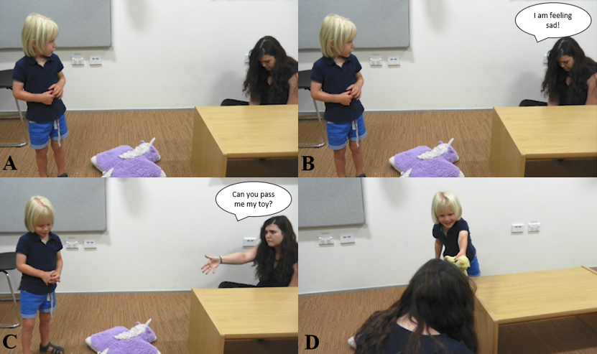
Note. Example of the cue phases and child helping during a helping task. Panel A: E1 signals sadness (cue 1). Panel B: E1 provides a verbal cue to signal sadness (cue 2). Panel C: E1 prompts the child to pass the target object (cue 3). Panel D: Child hands the target object to E1.

