Genetic ablation of the preptin coding portion of Igf2 impairs pancreatic function in female mice.

Supplementary Material

Authors list
Buckels, E.J.^{1, 2}, Hsu, H.-L.¹, Buchanan, C.M.^{1, 2}, Matthews, B.G.^{1, 2}, Lee, K.L.^{1, 2}

Affiliations (all departments/institutions where the work was done) with city and country
¹Department of Molecular Medicine and Pathology, University of Auckland, New Zealand.
²Maurice Wilkins Centre for Molecular Biodiscovery, University of Auckland, New Zealand.

Running head
Glucose metabolism in preptin knockout

Address for correspondence
Corresponding author: Dr Kate Lee
Email address: kathryn.lee@auckland.ac.nz
ORCID ID: https://orcid.org/0000-0001-6848-4767
Address: University of Auckland, Private Bag 92019, Auckland, New Zealand.
Supplementary Table 1: Organ weights.
Weights for the pancreas also include the spleen. The absolute kidney weight is for the left kidney only; this weight was doubled before calculating kidney weight relative to bodyweight, to account for the weight of the right kidney. Group numbers for brain only: female WT, n=8; female KO, n=6; male WT, n=9; and male KO, n=13. Data are means ± SEM. Abbreviations: wild-type (WT); knockout (KO); not significant (ns).
 | Female |  | Male |  | p value (genotype effect)
 | WT | KO | WT | KO | Female | Male
 | n=10-12 | n=11-12 | n=9 | n=13
Absolute organ weights
Kidney (mg) | 132 ± 3 | 134 ± 5 | 222 ± 8 | 201 ± 9 | ns | ns
Liver (mg) | 1135 ± 44 | 1207 ± 65 | 1638 ± 70 | 1604 ± 164 | ns | ns
Heart (mg) | 115 ± 3 | 132 ± 13 | 283 ± 33 | 231 ± 25 | ns | ns
Pancreas (mg) | 402 ± 16 | 411 ± 26 | 600 ± 51 | 521 ± 39 | ns | ns
Brain (mg) | 474 ± 10 | 506 ± 19 | 565 ± 26 | 545 ± 26 | ns | ns
Organ weights relative to bodyweight
Kidney (%) | 0.98 ± 0.03 | 1.02 ± 0.4 | 1.24 ± 0.05 | 1.17 ± 0.05 | ns | ns
Liver (%) | 4.18 ± 0.09 | 4.52 ± 0.20 | 4.55 ± 0.18 | 4.67 ± 0.09 | ns | ns
Heart (%) | 0.46 ± 0.03 | 0.51 ± 0.06 | 0.78 ± 0.09 | 0.67 ± 0.07 | ns | ns
Pancreas (%) | 1.51 ± 0.03 | 1.54 ± 0.08 | 1.65 ± 0.11 | 1.50 ± 0.08 | ns | ns
Brain (%) | 1.80 ± 0.07 | 1.93 ± 0.05 | 1.56 ± 0.04 | 1.58 ± 0.06 | ns | ns

Supplemental Figure 1: Mouse Igf2 locus and location of the knockout.
(A) Features of the mouse Igf2 locus; Mus musculus strain C57BL/6J chromosome 7, GRCm39, complement(142204505..142220566) NC_000073.7. The empty region of the red line indicates the regions of exon 3 and 4 and intervening intron removed in the knockout. Exons for all transcript variants 1-5 are indicated by the grey bars. Mir483 is indicated by the orange bar. The target region for the two Taqman assays used in this study are indicated in green, coding sequences (CDS) for isoform 1 and 2 are shown in maroon, and the position of the CDS for preptin is indicated in blue. (B) Features of the preptin KO allele including the position of an A to G mutation found when sequencing. The mutation is within an intron following the neo cassette, 3 bp upstream of the branch point required for splicing and 38 bp upstream of the knocked out exon. The potential branch site is still consensus.
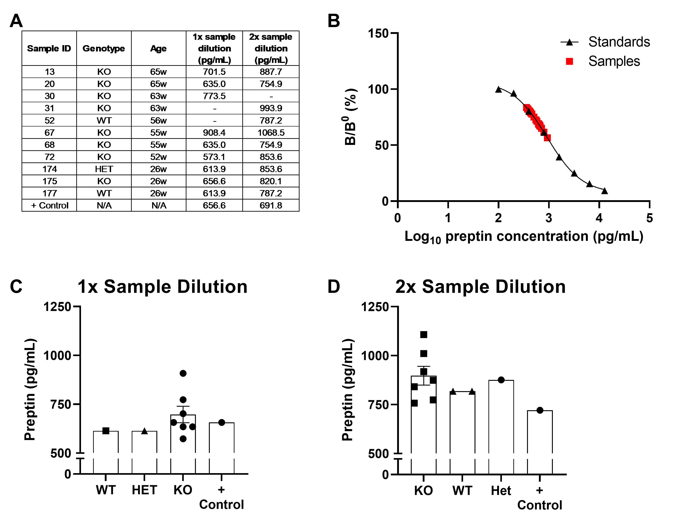
Supplemental Figure 2: Results of adult mouse serum testing using a Preptin (Human) - RIA Kit 1.5 µCi 125I (catalogue number RK-035-24, Phoenix Pharmaceuticals, CA).
Genotype and age of samples (A) tested at either 1× or 2× dilution (B-D). The protocol was performed according to manufacturer's instructions.
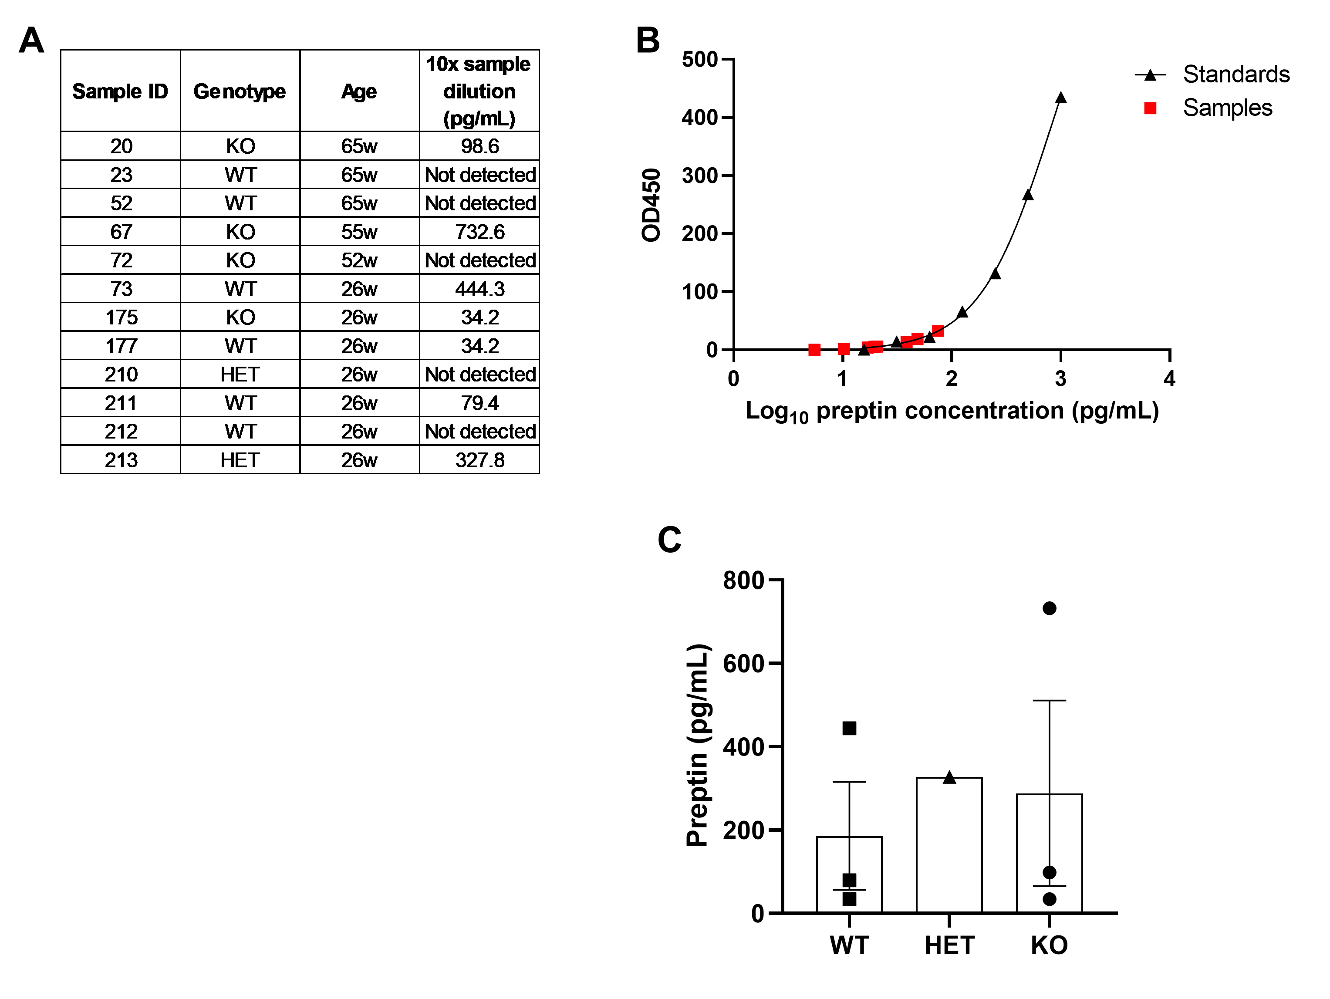
Supplemental Figure 3: Results of adult mouse serum testing using a Mouse Preptin ELISA kit (catalogue number EM1806, FineTest, Wuhan, China).
Genotype and age of samples (A) tested at 10× dilution (B-C). The protocol was performed according to manufacturer's instructions.

