Technical report: Machine learning the geometry of the inverse problem of electro cardiography
Peter Briesch, Brandon Wood
University of Auckland

Author Note
Supervised by Mark Trew, Avinash Malik and Tommy Peng. This is a report for the results, so far, of the attempt to machine learn the geometry of the inverse problem of electro cardiography

Abstract
Documented are the early results in our research for machine learning the geometry of the inverse problem of electrocardiography. Our early research has focused on a concentric circle model to describe the system, where a smaller circle representing the heart is put inside a larger circle representing the body. Using a forward model that was provided to us by Mark Andrews, we generated heart surface potentials (HSP) and body surface potentials (BSP) to use as training and testing data. Early testing focused on whether our machine learning (ML) model could predict HSP’s from BSP’s. With this being quite a simple task for a regression model results were very good with under 4% RMSE on testing data. We then moved on to creating a model that could encode for the geometry of the heart. The goal was to have our model predict both the x and y position of the circular heart and the position of the peak of the gaussian on the heart. These results were also very promising with an average RMSE for the prediction of the x and y position of the heart being about 0.6 and the prediction of the angle of the gaussian peak being 0.01.
Keywords: Machine learning, Inverse problem, Electro-cardiography

Technical report: Machine learning the geometry of the inverse problem of electro cardiography

Data generation
The first challenge of applying machine learning to the inverse problem is the dataset. As of time of writing, there is no significant dataset that contains paired body and heart surface recordings. Therefore, it is necessary to synthesize data for the neural network to learn from. By using a mathematical model based upon an in-vitro model of a pig heart suspended in a torso, we can create a forward model that generates these pairs for training.
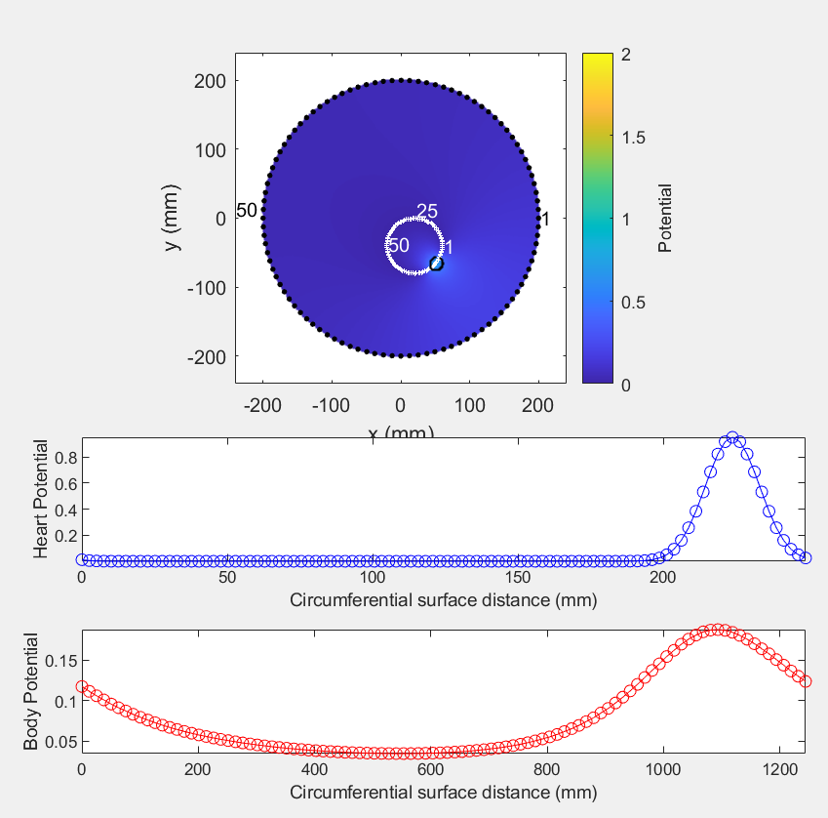
Figure 1: Simulator tool provided by Mark Trew

These BSP and HSP waveforms are discretized into 100 points and used to train the model. A dataset of 73,790 points was synthesized for training, testing and validation of the neural network. This is composed of 100 discrete points around the circumference of the heart with 5 variations of gaussian amplitude and width for the hearth potential for each point, repeating this iteration for x and y positional shifts of 10mm between 40 and -40mm.

Results
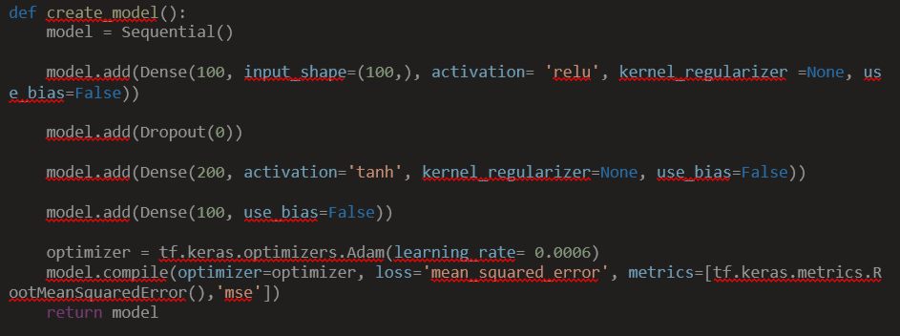
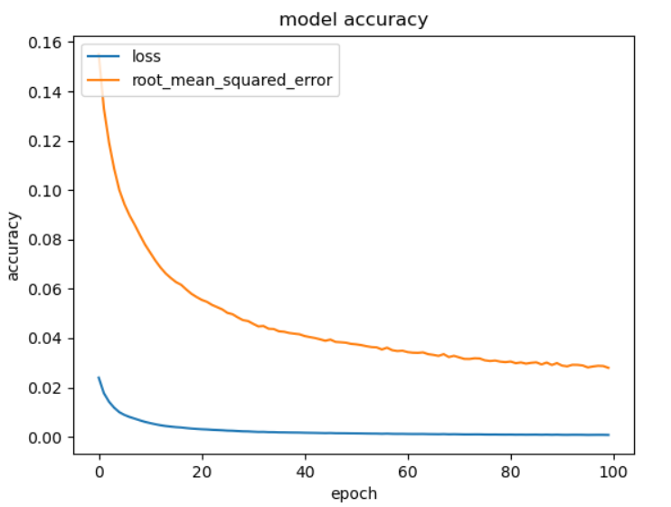
As we’ve stated, initially we focused on seeing if a machine learning model could reliable predict HSP’s from BSP’s and in hindsight this is actually quite simple for a regression model to predict. Especially as we found out that each HSP output has a unique enough BSP input, at least with the data that we generated, for the model to accurately predict the peak of the gaussian impulse.
Figure 3: Initial ML model for predicting HSP using BSP as input
Figure 2: Loss and RMSE of initial model
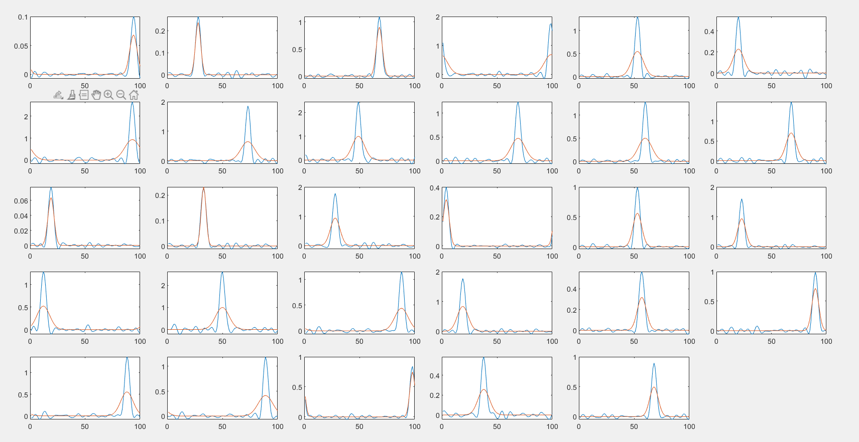
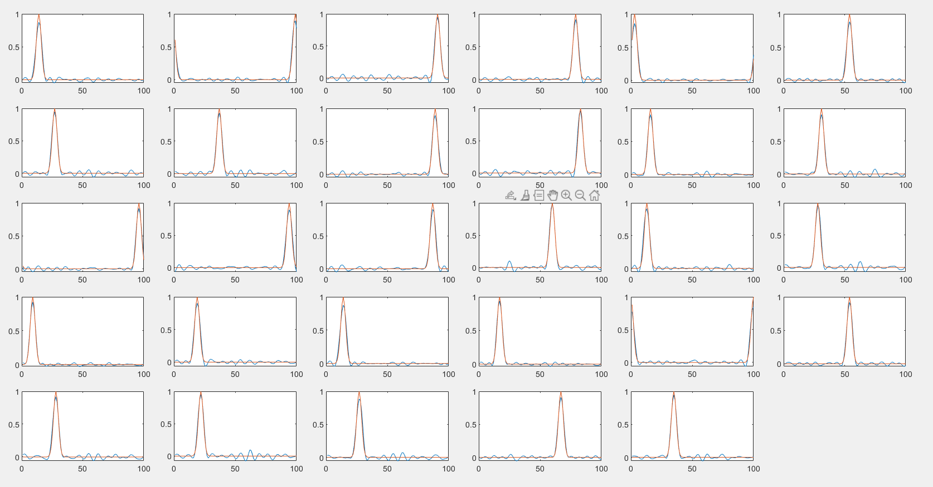
Figure 4: Initial model trained on regularized data set predicted on a testing set of varying gaussian amplitude
Figure 5: Gaussian impulse prediction (Blue) vs actual (Orange) for initial ML model. This is with a regularized training and testing set with gaussian amplitudes regularized to 1

Geometry Prediction:
Moving on to encoding the geometry of the heart was a little bit trickier as it needed more than a simple sequential model to output two separate predictions. The first model that we tried simply took two of the same BSP values as inputs and essentially trained two separate models with different activation functions and different outputs in parallel. The geometry output included the x and y position of the heart, as well as the angle of the gaussian on the hearts surface.

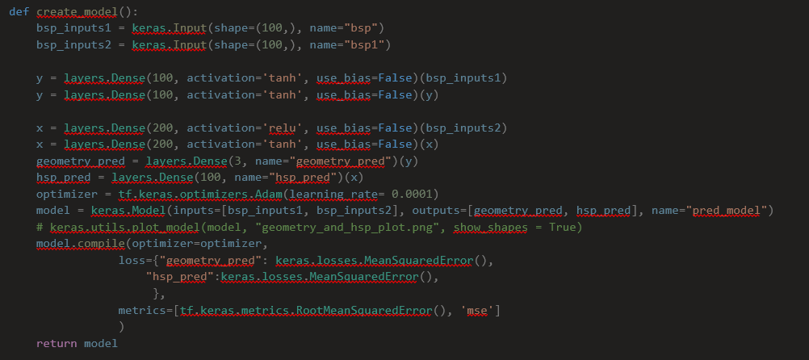
Figure 6: First model for predicting both HSP and heart geometry using two separate inputs both. Data included varying gaussian amplitude between 0 and 1 and regularized geometry.

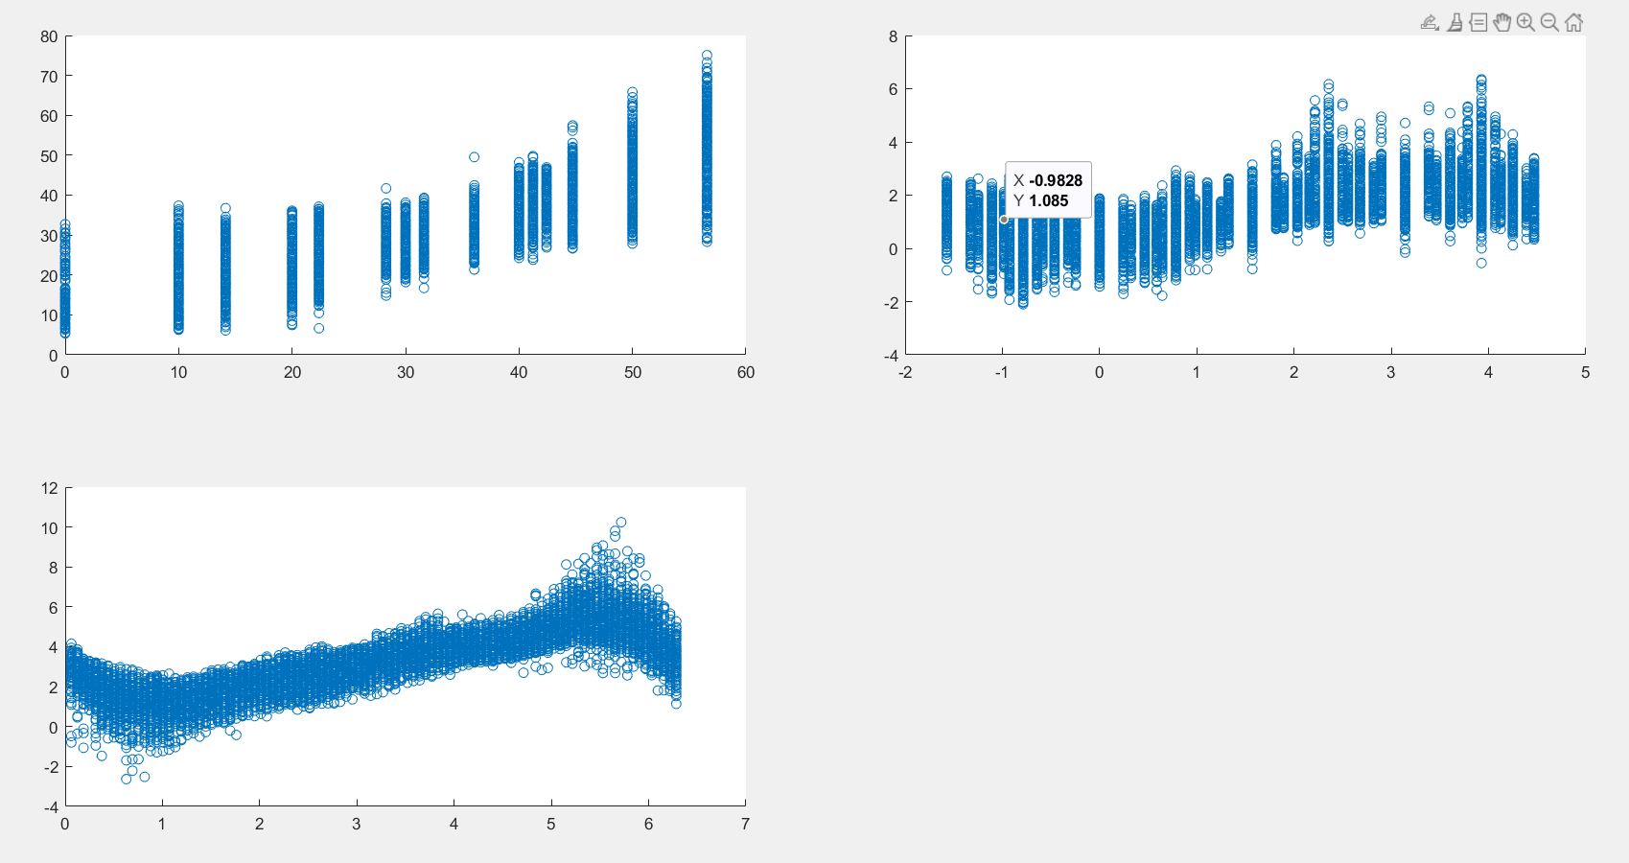
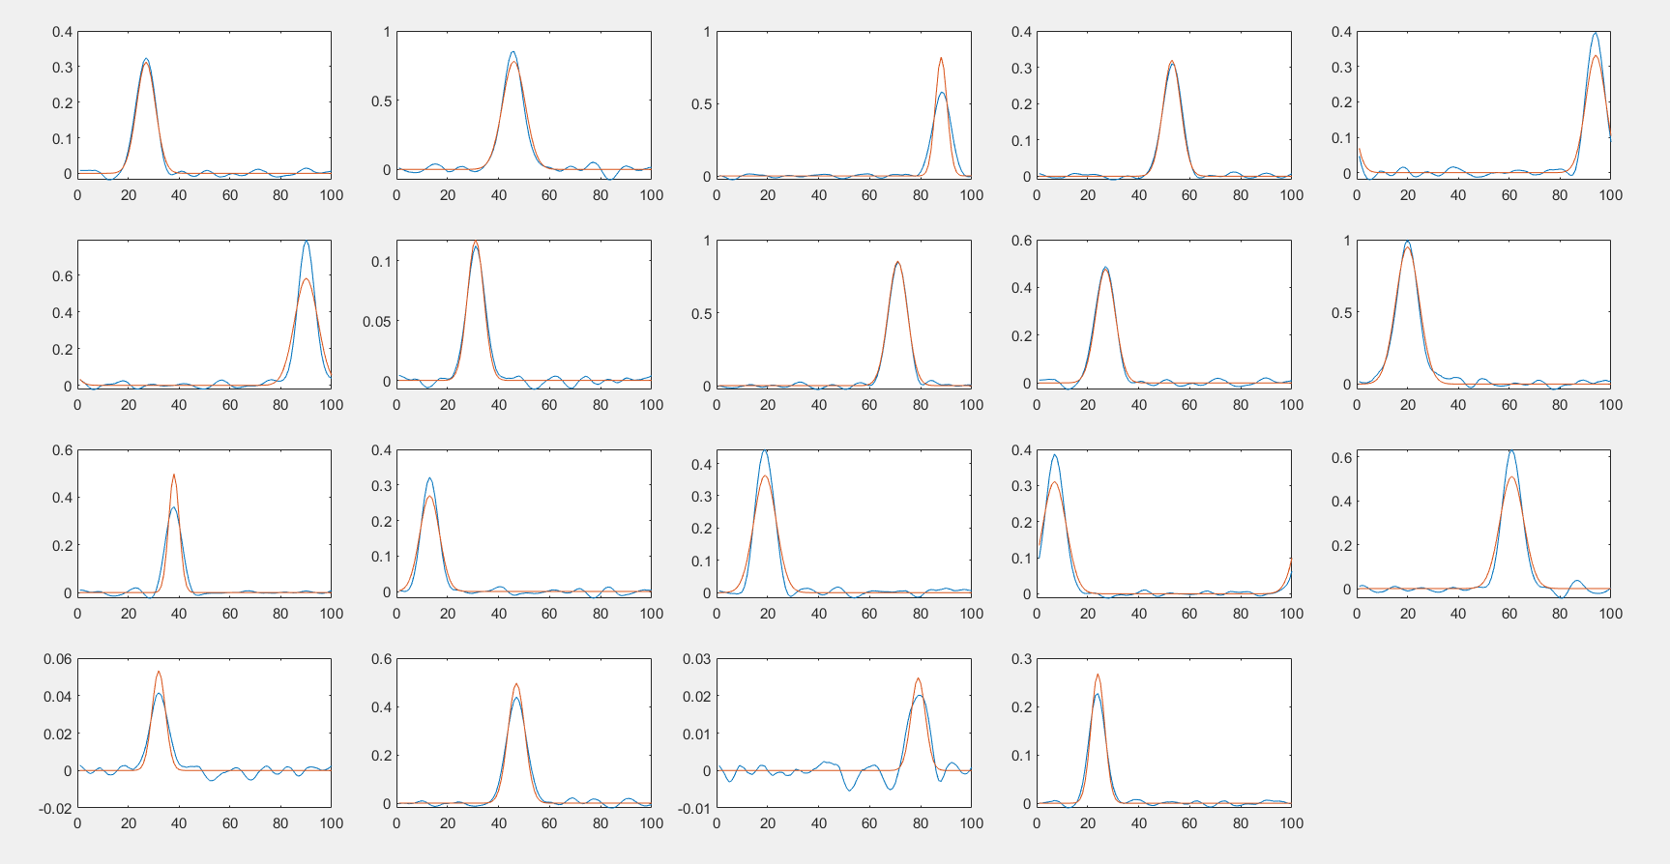
Figure 7: geometry predictions. Actual (x axis) vs predicted (y axis). x prediction, y prediction and gaussian angle prediction respectively.
Figure 8: Prediction results (Blue) vs actual (Orange). varying amplitude between 0 and 1

Geometry differentiation
It is statistically significant to determine for two similar heart gaussians how well the model can differentiate between them. Some cases where the heart waveforms end up being significantly similar due to different geometries allowing the same point in space to be replicated are examined, the generated points are exaggerated to increase similarity, then tested by having the model predict the corresponding HSP. The figure below shows two different BSPs on the left, with the blue occurring at 20,40 and the red occurring at 0,40. Despite the location difference the location of the heart gaussian on the simulated circumference causes these two similar waveforms. The graph on the right shows the HSP prediction of both blue and red waveforms: the ‘o’s map true values while the ‘x’s map predicted values. Despite the similar BSPs the neural network is clearly able to predict the slight change in the gaussian peak – there is some error in the amplitude but the central values are clearly matched.
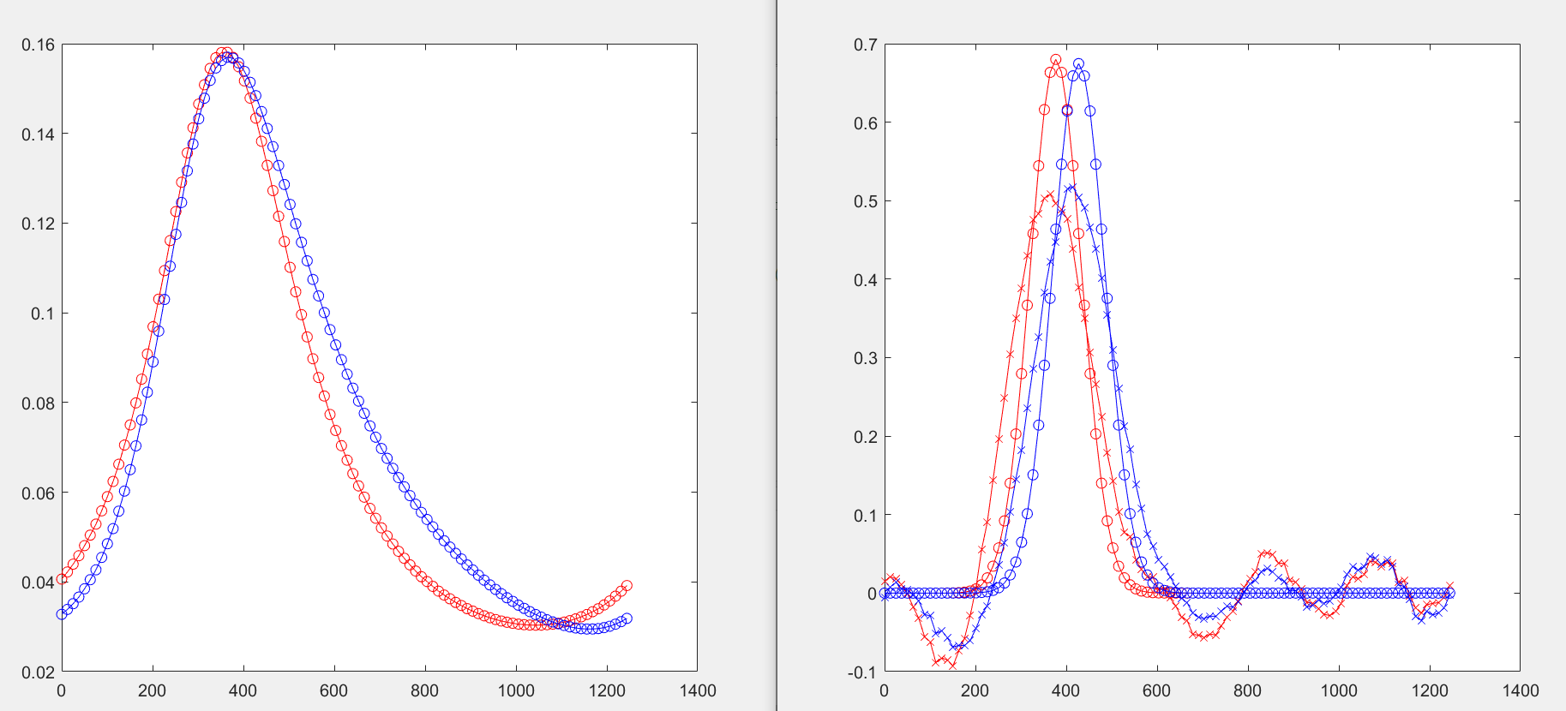
Figure 9: MATLAB visualization of test predictions, true BSPs on left, HSPs true/predicted on right

Final Model:
The latest ML model manages to produce very promising results for predicted both the HSP and geometry of the heart. At first we tried a model where the inputs would be passed through the usual activation functions that we have been using for predicting HSP’s. The model would then branch into one branch that would go straight to an output layer for the HSP predictions and the second branch would carry on through two more activation functions before passing into the output layer for the geometry predictions. We found this model to have slightly worse than usual HSP predictions with greater variation in the gaussian peaks. However, it has much better geometry prediction than previous models. The only downfall was that it had trouble predicting the angle of the gaussian on the hearts surface as shown in figure 9.
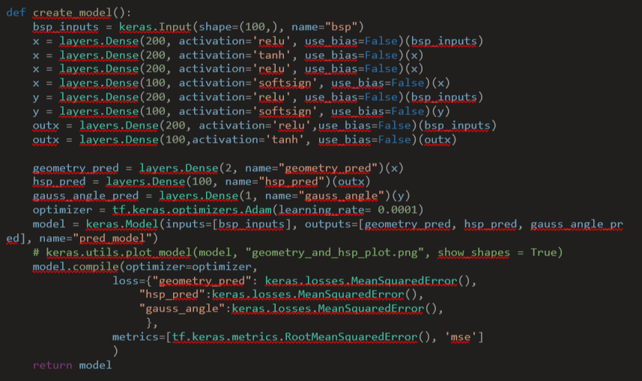
Figure 108: Final model for predicting HSP and heart geometry from BSP inputs

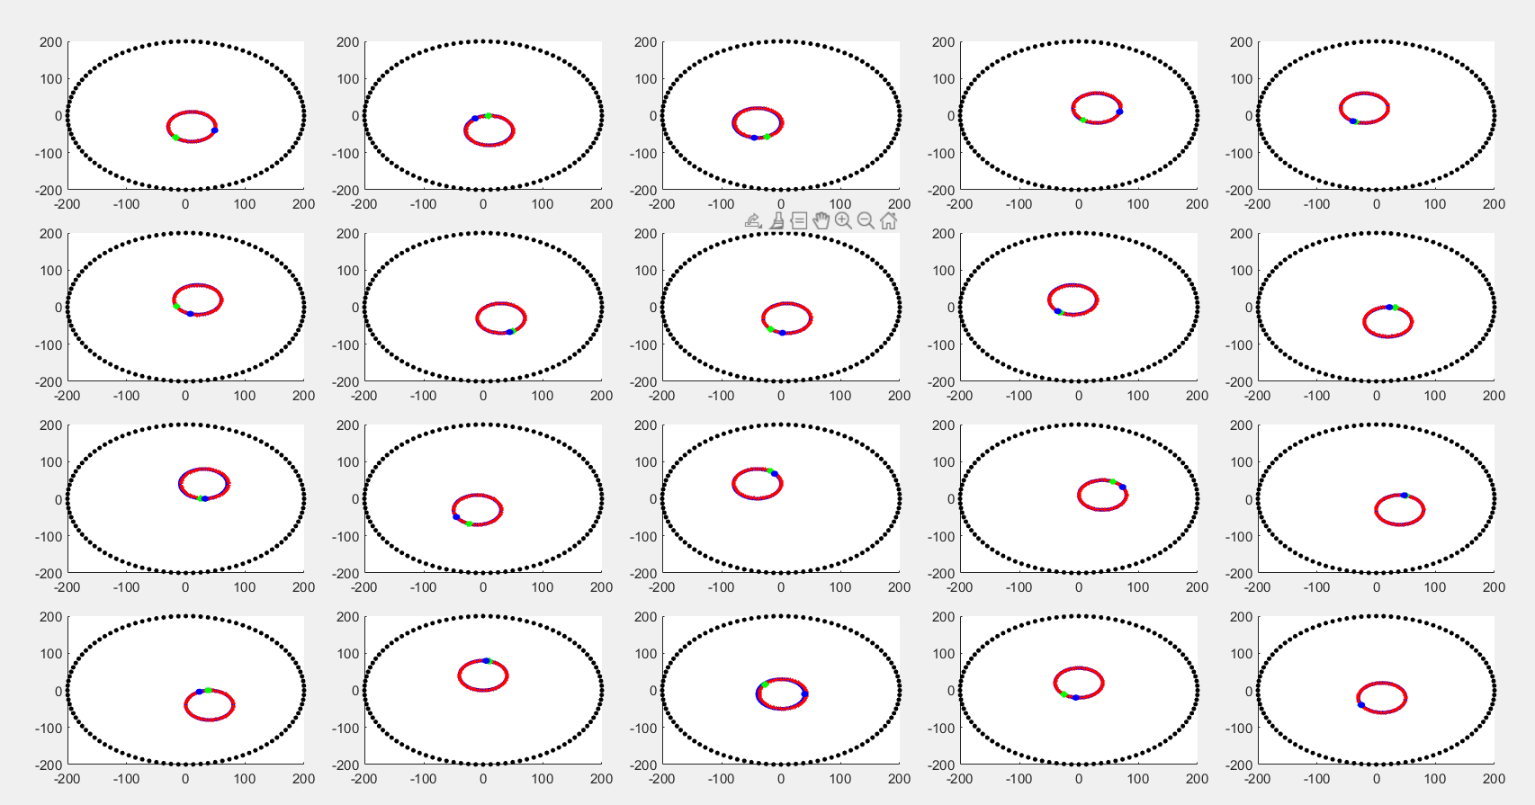
Figure 11: Heart geometry prediction results. Actual x and y position (Red) vs Predicted x and y position (Blue). Also shown is the prediction result for the position of the gaussian peak on the hearts surface. Predicted (Green) vs Actual (Blue)
The final model that gave us the best results for both HSP predictions and geometry predicitons split the model into making 3 separate predictions. HSP prediction, x and y position prediction, and gaussian angle prediction. As can be seen in figure 8 the model takes 100 data points for the BSP input. This input is essentially fed into three models with different activation functions and depth. All activation functions were searched for using a GridCV search method using some of the most popular activation functions. Hyper paramteres were also tuned using GridCV. Ultimately the model gives three outputs and as you can see from figures 10, 11 and 13. Throughout the different models we consistantly see that the model struggles to predict the exact gaussian (Fig 3, 4, 7, 11) for each BSP gaussian. However, we aren’t that concerned about this because as long as the model can accurately predict the gaussian peak for medical applications this is fine and clearly shown in Fig 11 the model has no trouble with this.

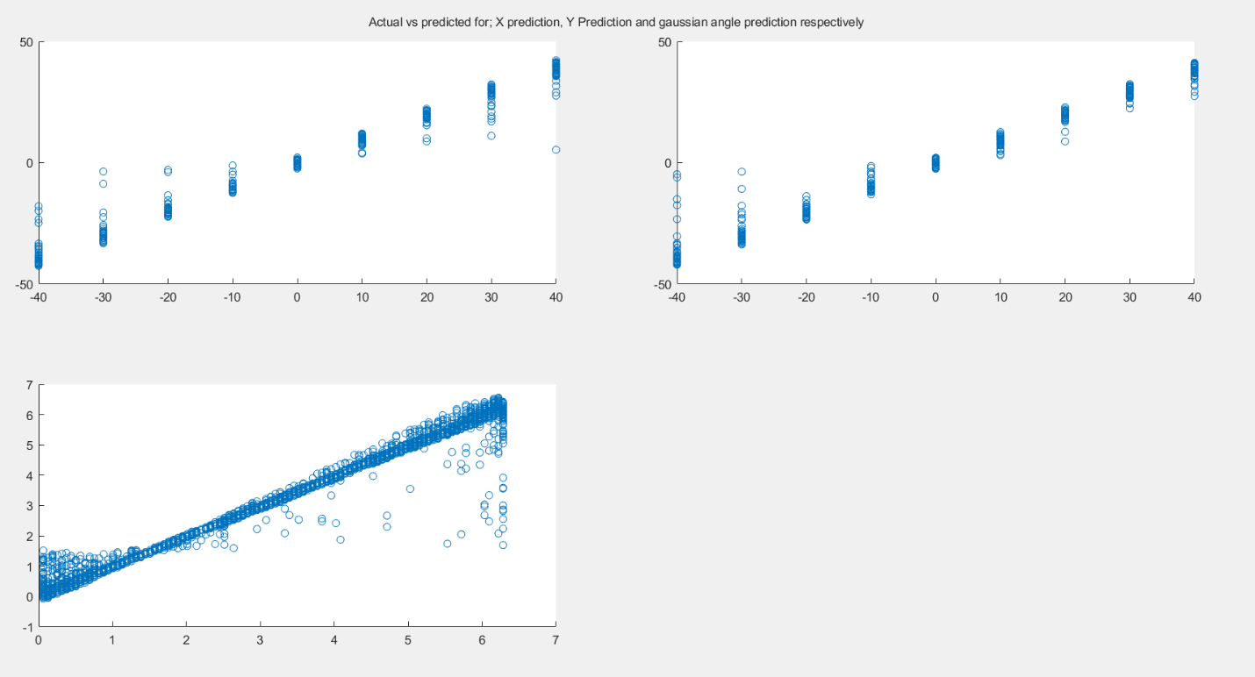
Figure 3: x prediction y prediction and gaussian angle prediction respectively for the final model.
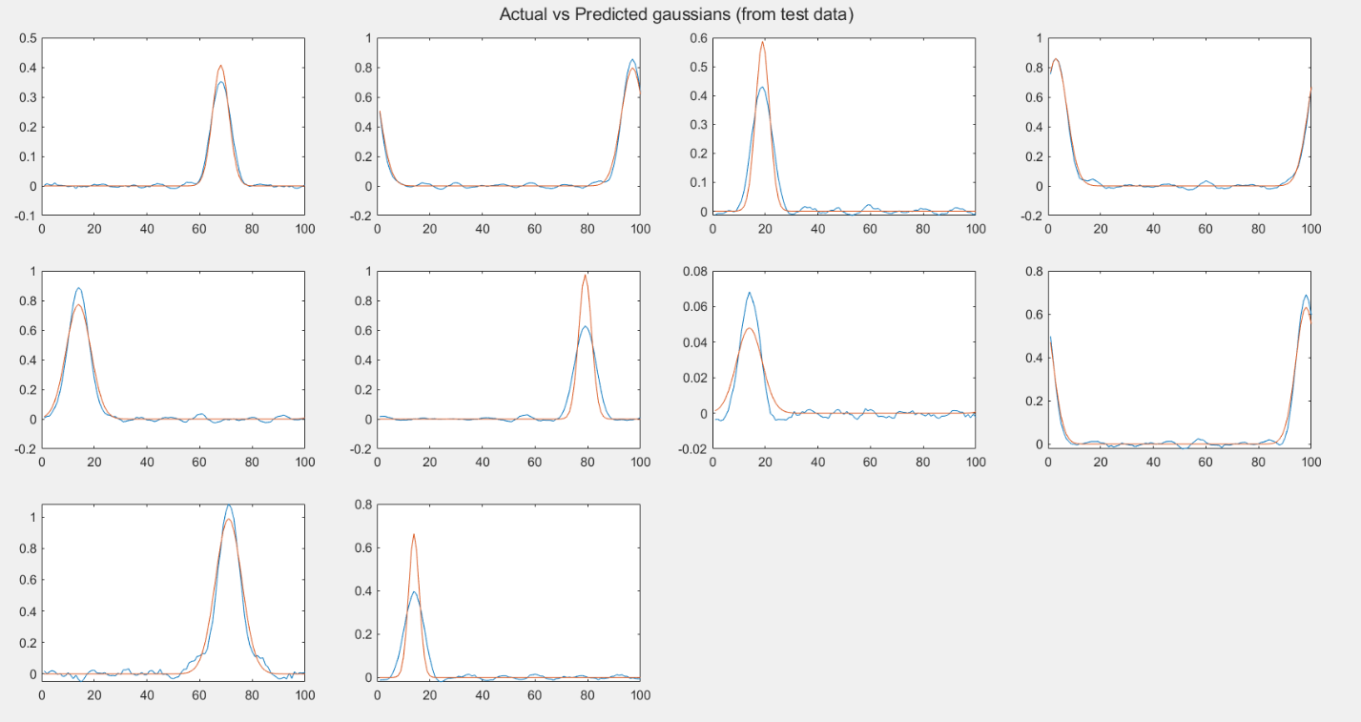
Figure 13: HSP predictions using the final model. Varying gaussian amplitude between 0 and 1 as well as varying gaussian width
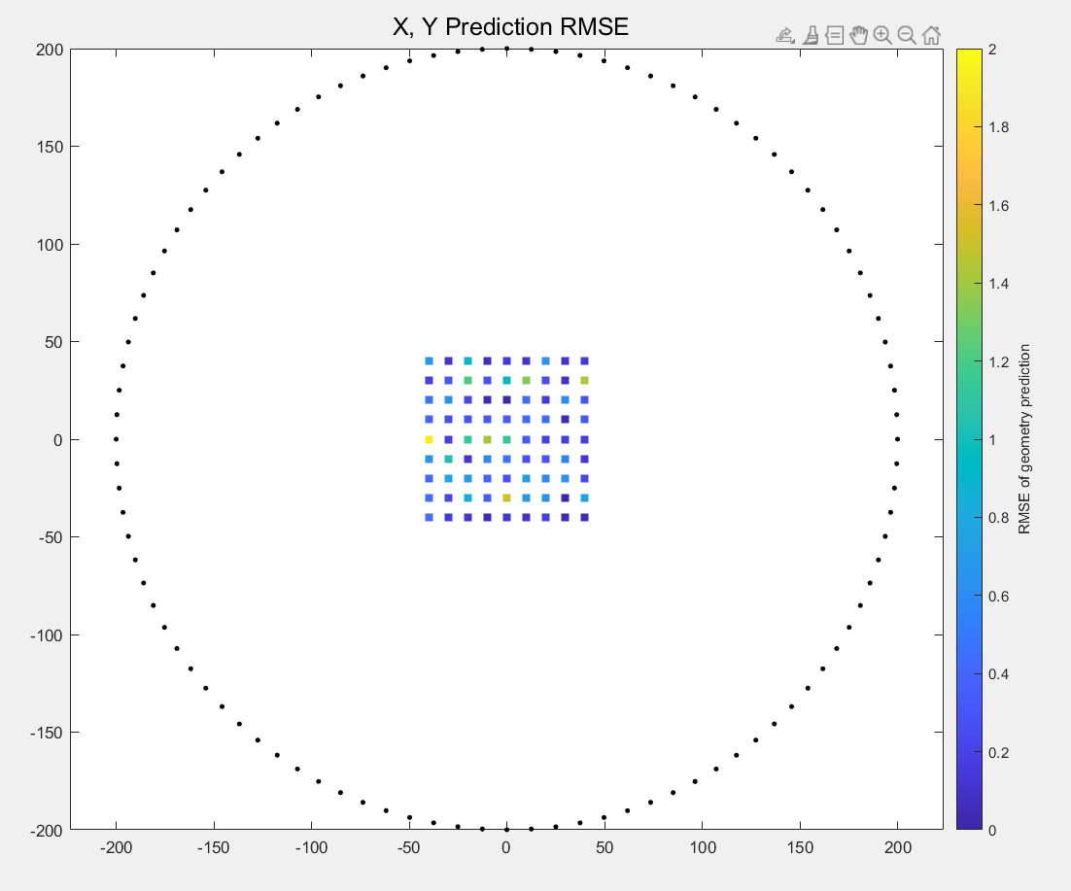
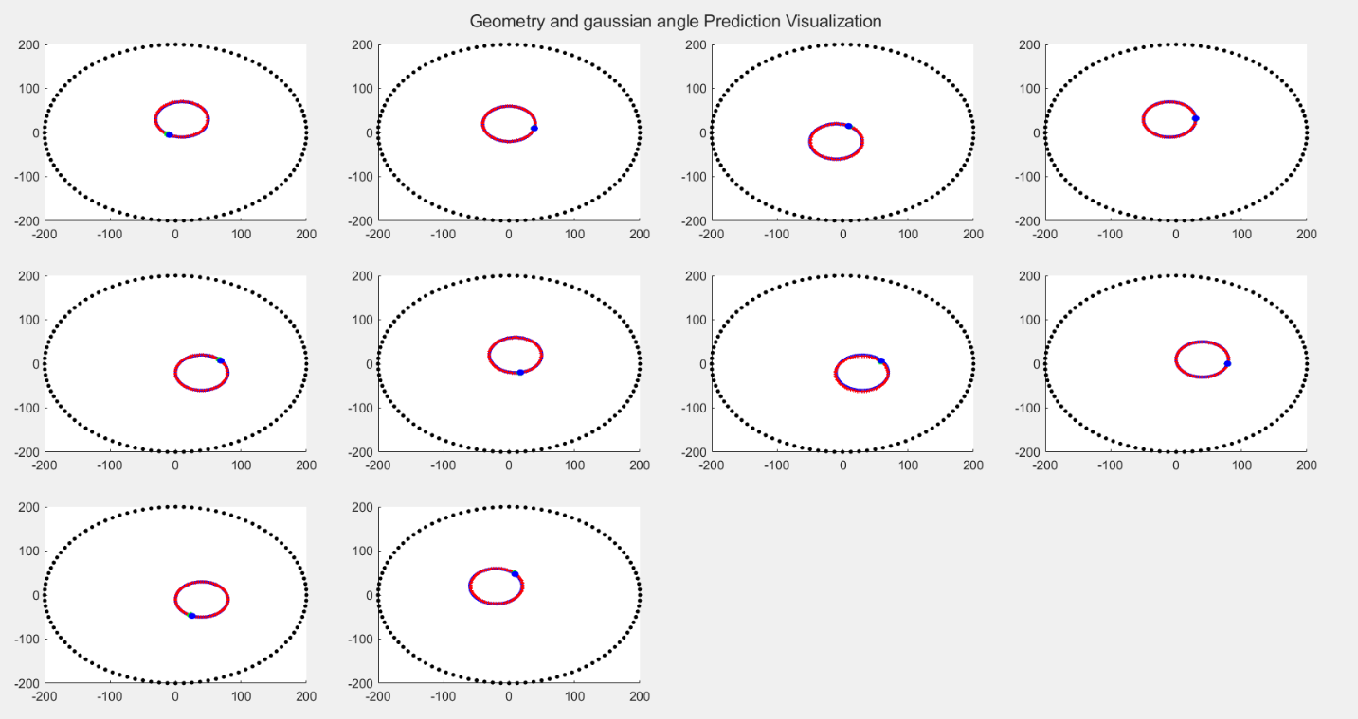
Figure 14: Heat map of RMSE for each x and y prediction for the heart.
Figure 15: Heart x and y position. With gaussian angle position prediction shown on hearts surface.
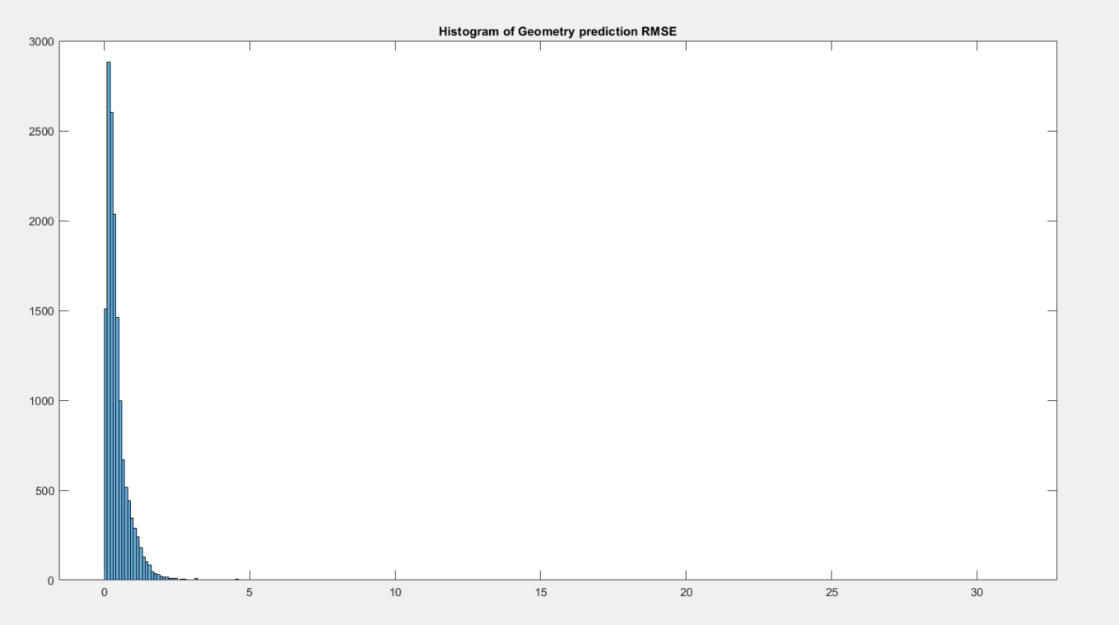
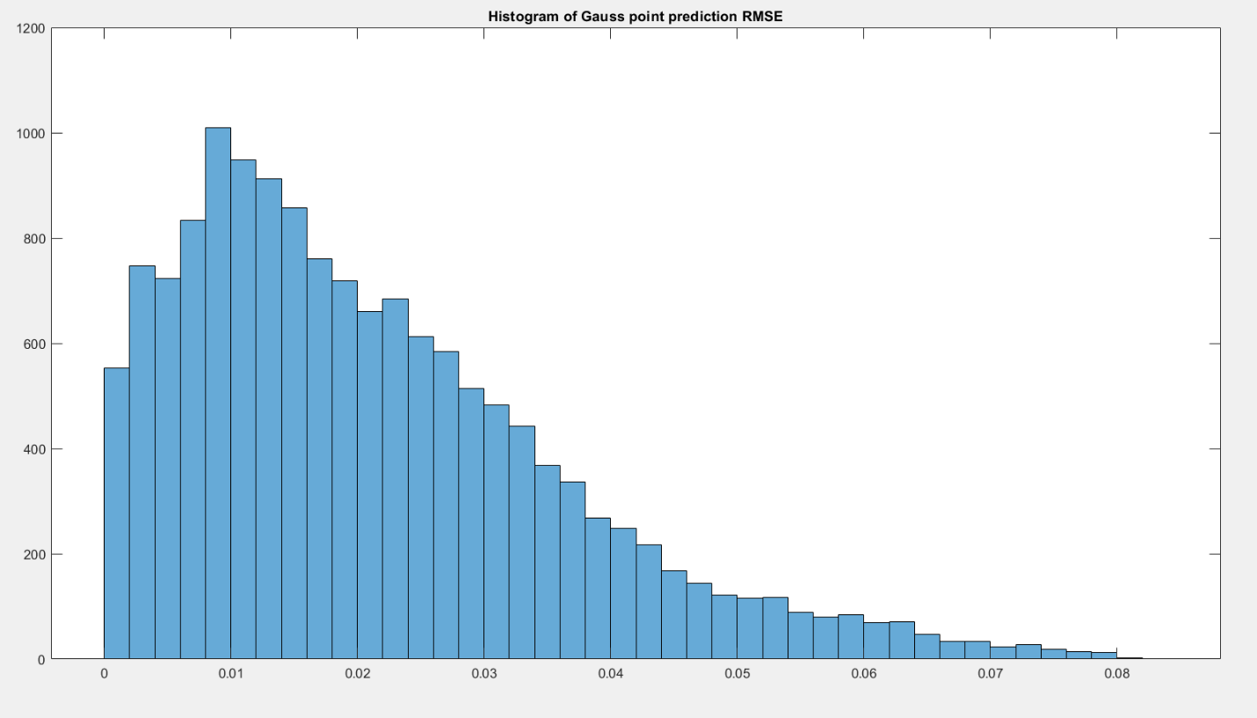
Figure 16: Histograms showing the RMSE heart position prediction and gaussian peak prediction

References
Peng, T, Malik, A, Trew, M, Bear, L (2020). Impulse data models for the inverse problem of electrocardiography.

