Sexually dimorphic changes in the endocrine pancreas and skeletal muscle in young adulthood following intra-amniotic IGF-I treatment of growth-restricted fetal sheep

Supplementary Material

Authors list
Emma J. Buckels,¹ Frank H. Bloomfield,¹ Mark H. Oliver,¹ Ana-Mishel Spiroski,¹ Jane E. Harding,¹ and Anne L. Jaquiery¹

Affiliations (all departments/institutions where the work was done), with city and country
¹The Liggins Institute, University of Auckland, Auckland, New Zealand

Running head
Pancreas and muscle following IGF-I treatment of FGR lambs

Address for correspondence
Corresponding author: Anne L. Jaquiery: Liggins Institute, University of Auckland, Private Bag 92019, Auckland, New Zealand. Email: a.jaquiery@auckland.ac.nz

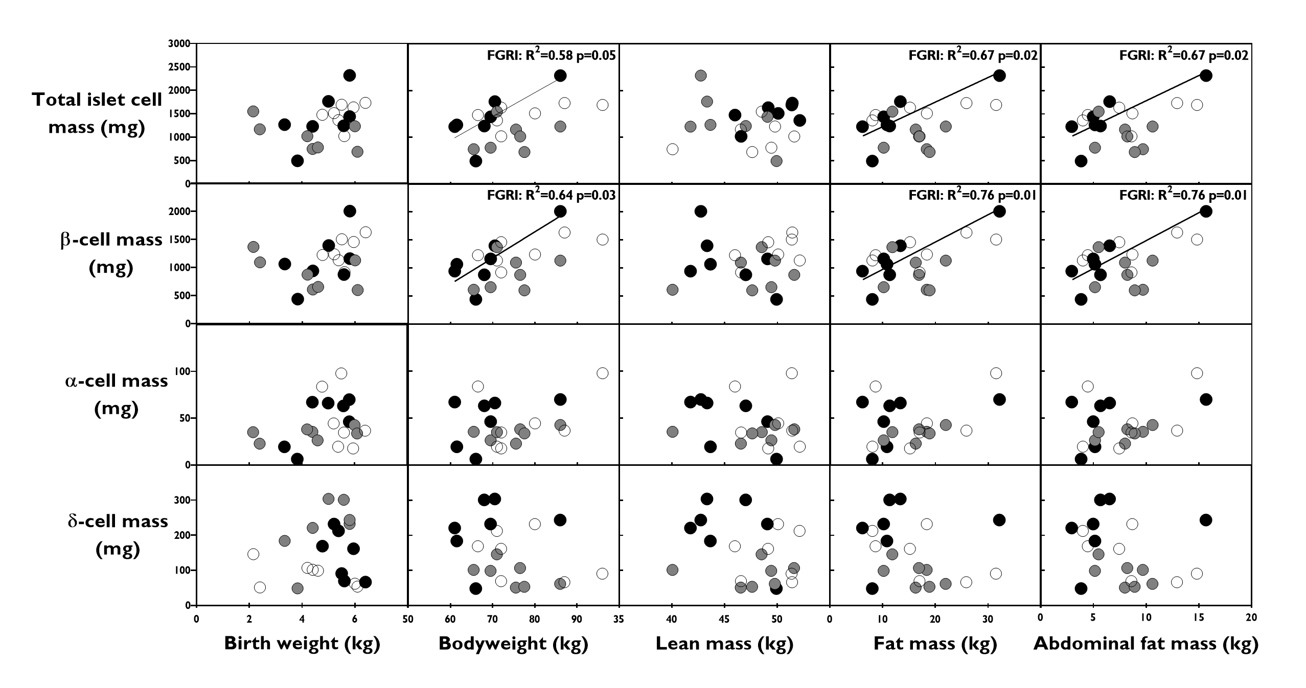
Supplementary Figure 1.
Scatter plots of pancreatic endocrine cell mass vs. bodyweight and composition at 18-months of age in female CON (white, n=7), FGRS (grey, n=7), and IGFI (black, n=7) sheep. Statistically significant correlations are indicated.

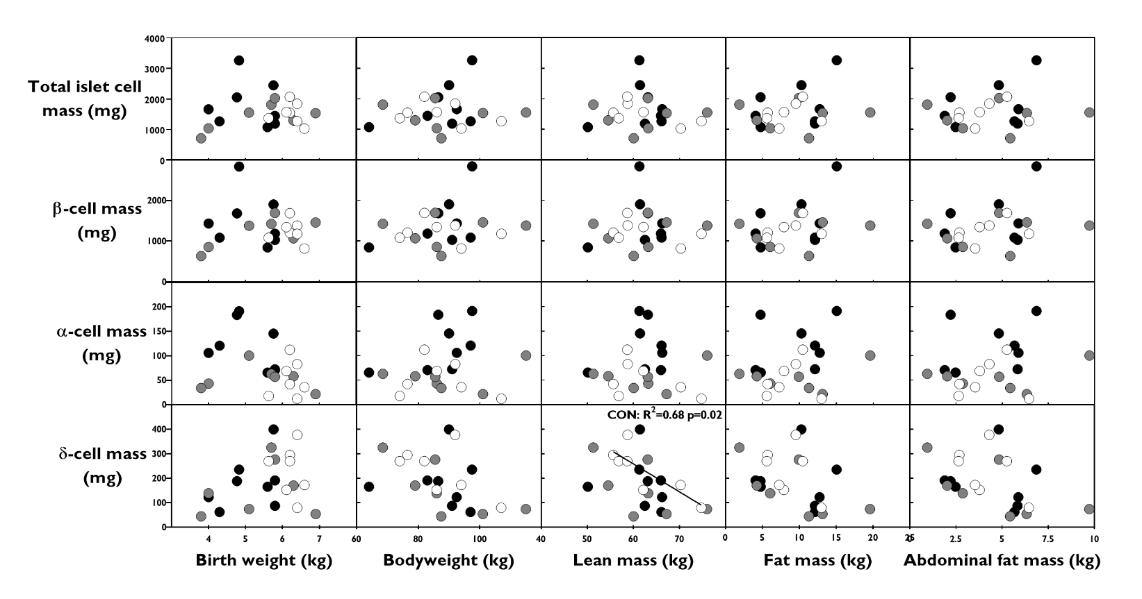
Supplementary Figure 2.
Scatter plots of pancreatic endocrine cell mass vs. bodyweight and composition at 18-months of age in male CON (white, n=7), FGRS (grey, n=7), and IGFI (black, n=8) sheep. Statistically significant correlations are indicated.

Supplementary Table 1.
Primer and probe sequences for genes of interest.
Gene name  (gene symbol) | Accession ID  (species) |  | Sequence  (5’-3’) | Size  (base pairs)
AKT Serine/Threonine Kinase 2  (AKT2) | NM_001206146.1  (Bos Taurus) | F  R  P | CCCGAGCGAGGTGACA  CCAGCCTTCTTTGATGACAGACA  TCACGCTGCCACCATGA | 67
Forkhead box O1  (FOXO1) | XM_012184536.2  (Ovis Aries) | F  R  P | GTCAACATCCGCAGTCAATGG  GGGCCAGGCGGTTCATA  CCCCACGCTGTAAAC | 83
Glucokinase  (GCK) | NM_001102302.1  (Bos Taurus) | F  R  P | TGTGAGGTTGGCATGATTGTG  TCTGCATCTCCTCCATGTAGCA  CACGGGCTGCAACG | 61
Glutathione peroxidase  (GPX) | L10325.1  (Bos Taurus) | F  R  P | ACATCCGGTGGAACTTTGAGAAG  GGTGGTACCAGCGCATGAT  CAGACGGCATCCCC | 69
Insulin  (INS) | AH005355.3  (Ovis Aries) | F  R  P | GCAGAAGCGTGGCATCGT  TTACAGTAGTTCTCCAGCTGGTAGAGA  AGCAGTGCTGCGCC | 72
Insulin Receptor  (INSR) | AJ844652.1  (Ovis Aries) | F  R  P | CCCCAACCTCACGGTCATC  CTCCTTCAGGTGAACCATCTCA  CTCGCGCCTCTTCTT | 82
Insulin Receptor Substrate 1  (IRS-1) | EU681268.1  (Sus Scrofa) | F  R  P | GAAGTGGCGGCACAAGTC  GCCCGCTTGTTGATGTTGAAG  AAACGCTCGATCCCC | 77
Insulin like growth factor 1  (IGF1) | NM_001009774.3  (Ovis Aries) | F  R  P | CTTCCGGAGCTGTGATCTGA  TGAGCGGGCCGACTTG  CTGTGCGCCTCTCAAG | 73
Insulin like growth factor 2  (IGF2) | NM_001009311.1  (Ovis Aries) | F  R  P | CGAGGCATCCAGCGATTAG  TAGATGGTGTCACTTGGCAGAATT  AGTGAGCCAAAGTGTC | 62
Insulin like growth factor 1 receptor  (IGF1R) | AY162434.1  (Ovis Aries) | F  R  P | TCTAACTTTGTCTTTGCAAGAACCA  TCACTGGCCCAGGAATGTC  CCTGCAGAAGGAGCAG | 64
Potassium Voltage-Gated Channel Subfamily J Member 11  (KCNJ11) | NM_001081598.1  (Bos Taurus) | F  R  P | GCAAGGCCGCTTCCTACA  GTGTATGGCCACTTGAGATCCA  CCAGCGTGGTGAACAC | 60
Mitochondrially encoded ATP synthase membrane subunit 6  (MTATP6) | DQ320100.1  (Ovis Aries) | F  R  P | AGGCATGGCCATTCCTTTATGAG  GAAATGGGCGAGTGAAGCTTT  CTTCCGCAACAAAACT | 79
Nuclear Respiratory Factor 1  (NRF1) | AF233354.1  (Ovis Aries) | F  R  P | GTTCGGTGCAGCTCCTTTG  CTTCCAGGATCATGCTCTTGTACTT  ACGCACCACATTCTC | 59
PPARG Coactivator 1 Alpha  (PPARGC1A) | NM_177945.3  (Bos Taurus) | F  R  P | TGTTTATAAATTCAGGACTAGCCATGGATG  AATGAATAGGACTGCGTGCCA  CTTCGCTGTCATCAAAC | 103
PI3K Catalytic Subunit Beta  (PIK3CB) | NM_001206047.1  (Bos Taurus) | F  R  P | TCCGGAACTGTGTAATGAACAGAAC  TGTTCATACAGCTTCTTGATCTTGCA  CATTCCACAAGTATAAAATG | 79
Protein Kinase C Zeta  (PRKCZ) | NM_001077833.2  (Bos Taurus) | F  R  P | GCCGTGGAGCCAGAAGAT  GCGCTTGGCCTGGAAGA  TTGGCGCGGTACAGCT | 65
Peroxisome Proliferator Activated Receptor Gamma 1  (PPARG) | KF727439.1  (Ovis Aries) | F  R  P | TGCCACAGGCCGAGAAG  GGTCGATGTCGCTGGAGATC  CCGCTAACAGCTTTTC | 54
Solute Carrier Family 2 Member 2  (SLC2A2) | AJ318925.1  (Ovis Aries) | F  R  P | GCTCTTCACCAATGCCAGCTA  GCCGCATGCAGCATCAAT  CCGACAGCCTATTCTAG | 60
Solute Carrier Family 2 Member 4  (SLC2A4) | AY949177.1  (Ovis Aries) | F  R  P | GTCAACACAGTCTTCACCTTAGTCT  CCAGGCCCAGGAGATGGA  CCAGCCCGTTCCACC | 79
Somatostatin  (SST) | NM_001009196.1  (Ovis Aries) | F  R  P | CTGCTGTCTGAACCCAACCA  GCAGCCTGGGACAAATCTTCA  CAGGGCATCGTTCTCT | 65
Transcription Factor A  (TFAM) | XM_015104510.1 (Ovis Aries) | F  R  P | TGCGTATGTTCCAAAATGGTTTTCA  GCTGTTCTTTAGAAAACCGAACGT  CAGCTTGAGTGGTTATCC | 89
Uncoupling Protein 2  (UCP2) | NM_001280682.1 (Ovis Aries) | F  R  P | AGCCAACGGATGTGGTGAAG  CTCAACAGTGCTCTGGTACCT  CCTGCGCTTGGAACC | 80
Beta-Actin  (ACTB) | NM_001009784.1 (Ovis Aries) | F  R  P | ACCAGTTCGCCATGGATGATG  CCGGAGCCGTTGTCAAC  ATATTGCTGCGCTCGT | 55
Peptidylprolyl Isomerase A  (PPIA) | AY251270.1  (Ovis Aries) | F  R  P | GTACTGGTGGCAAGTCCATCT  CAGGACCTGTATGCTTCAGAATGA  ATGGCGAGAAATTTG | 72
Glyceraldehyde-3-Phosphate Dehydrogenase  (GAPDH) | NM_001190390 (Ovis Aries) | F  R  P | GGGCTGCTTTTAATACTGGCAAA  CATGTAGACCATGTAGTGAAGGTCAA  CATCGTTGCCATCAATG | 80
Ribosomal Protein L19  (RPL19) | AY158223.1  (Ovis Aries) | F  R  P | CAAAAACAAGCGGATTCTCATG  GCTTCTTGCGAGCCTTGTCT  AACATATCCACAAGCTGAA | 65
Tyrosine 3-Monooxygenase/ Tryptophan 5-Monooxygenase Activation Protein Zeta  (YWHAZ) | AY970970.1  (Ovis Aries) | F  R  P | GAGGGTCGTCTCCAGTATTGAG  TTCTCGAGCCATCTGCTGTTTT  CAGCACCTTCCGTCTTT | 67

Forward (F), reverse (R), and probe (P) sequences for genes of interest and reference genes.

