Analysing a test with packages in R
Classical Test Theory
Item Difficulty
#no new library has to be invoked these are part of base package
#use na.rm=true only if missing data present, otherwise drop
item_diff<-colMeans(MTcsv_noID, na.rm=true)
round(item_diff, 3)
V1 | V2 | V3 | V4 | V5
0.787 | 0.392 | 0.379 | 0.552 | 0.571

Item Discrimination
##first create a total score for each person
total_score<-rowSums(MTcsv_noID)
##correlate each item with the total score
item_discr<-cor(MTcsv_noID, total_score)
##display item discrimination values
item_discr
[,1]
V1 0.012824108
V2 0.535991439
V3 0.322218523
V4 0.120527496
V5 0.094385108….

Test Statistics
## invoke psych package in R
library(psych)
#this command calculates cronbach’s alpha for the whole data set as one factor
> alpha(MTcsv_noID, keys=NULL,cumulative=FALSE, title=NULL, max=10,na.rm = TRUE, check.keys=FALSE,n.iter=1,delete=TRUE,use="pairwise",warnings=TRUE,n.obs=NULL)
Some items ( V1 V4 V5 V6 V7 V9 V11 V12 V13 V14 V15 V17 V20 V21 V23 V25 V26 V28 V29 V33 V34 V39 V40 V42 V46 V48 V50 ) were negatively correlated with the total scale and probably should be reversed. To do this, run the function again with the 'check.keys=TRUE' option
Reliability analysis
raw_alpha std.alpha G6(smc) average_r S/N ase mean sd median_r
0.71 0.68 0.83 0.042 2.2 0.02 0.48 0.12 -0.012
lower alpha upper 95% confidence boundaries
0.67 0.71 0.75
Reliability if an item is dropped:
raw_alpha std.alpha G6(smc) average_r S/N alpha se var.r med.r
V1 0.72 0.69 0.84 0.044 2.3 0.020 0.086 -0.012
V2 0.69 0.66 0.82 0.039 2.0 0.022 0.080 -0.012
V3 0.70 0.68 0.83 0.041 2.1 0.021 0.085 -0.013
V4 0.72 0.69 0.83 0.043 2.2 0.020 0.082 -0.012
V5 0.72 0.69 0.83 0.043 2.2 0.020 0.082 -0.012
Item statistics
n raw.r std.r r.cor r.drop mean sd
V1 375 0.0128 0.023 -0.0496 -0.0560 0.787 0.410
V2 375 0.5360 0.508 0.5329 0.4736 0.392 0.489
V3 375 0.3222 0.312 0.2790 0.2464 0.379 0.486
V4 375 0.1205 0.131 0.1043 0.0372 0.552 0.498
V5 375 0.0944 0.111 0.0825 0.0112 0.571 0.496….
#note the warnings on items that are negatively correlated; in CTT those items should be deleted and run again.
# rerun with inverse discrimination items reversed; don’t do this unless you KNOW that the item was negatively loaded.
Call: alpha(x = MTcsv_noID, keys = NULL, cumulative = FALSE, title = NULL,
max = 10, na.rm = TRUE, check.keys = TRUE, n.iter = 1, delete = TRUE,
use = "pairwise", warnings = TRUE, n.obs = NULL)

raw_alpha std.alpha G6(smc) average_r S/N ase mean sd median_r
0.94 0.93 0.96 0.21 14 0.0043 0.49 0.23 0.16

lower alpha upper 95% confidence boundaries
0.93 0.94 0.95
Reliability if an item is dropped:
raw_alpha std.alpha G6(smc) average_r S/N alpha se var.r med.r
V1- 0.94 0.93 0.96 0.22 14 0.0043 0.039 0.17
V2 0.93 0.93 0.95 0.21 13 0.0045 0.037 0.15
V3 0.94 0.93 0.96 0.22 14 0.0043 0.039 0.16
V4- 0.94 0.93 0.95 0.21 13 0.0044 0.039 0.16
V5- 0.94 0.93 0.95 0.21 13 0.0044 0.039 0.16
Item statistics
n raw.r std.r r.cor r.drop mean sd
V1- 375 0.111 0.114 0.081 0.075 0.21 0.410
V2 375 0.735 0.735 0.740 0.715 0.39 0.489
V3 375 0.332 0.330 0.307 0.293 0.38 0.486
V4- 375 0.531 0.532 0.525 0.499 0.45 0.498
V5- 375 0.563 0.566 0.560 0.532 0.43 0.496
Non missing response frequency for each item
0 1 miss
V1 0.21 0.79 0
V2 0.61 0.39 0
V3 0.62 0.38 0
V4 0.45 0.55 0
V5 0.43 0.57 0
Warning message:
In alpha(MTcsv_noID, keys = NULL, cumulative = FALSE, title = NULL, :
Some items were negatively correlated with total scale and were automatically reversed.
This is indicated by a negative sign for the variable name.

#test info
describe(total_score)
n | M | SD | median | min | max | skew | kurtosis | se
375 | 23.78 | 5.96 | 23 | 7 | 41 | 0.45 | -0.29 | 0.31
SEM=SD*√(1-reliability); =5.96*√(1-.712)=5.96*.537=3.20
## item characteristic curves
x <- mirt(MTcsv_noID, 1, SE=TRUE)
Iteration: 301, Log-Lik: -8700.584, Max-Change: 0.00010
plot(x)
plot(x, type = 'trace')

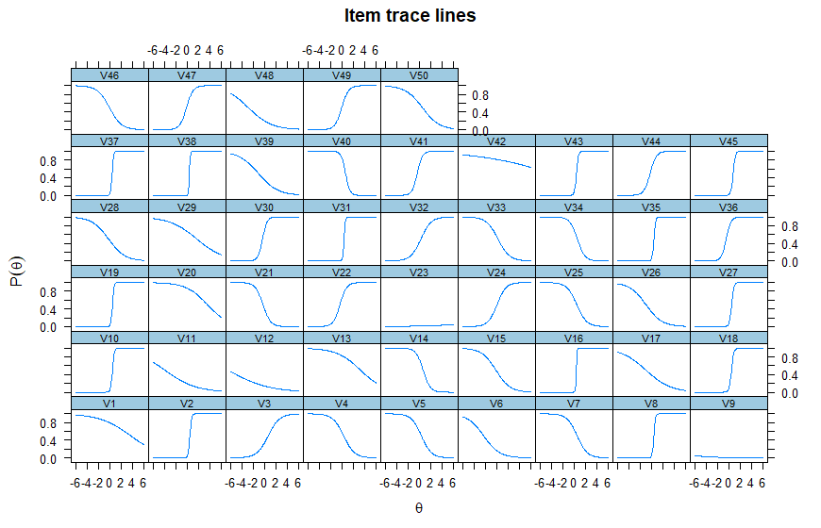
QUESTION
Do trace lines match the items negatively correlated with the total scale?

1 parameter Rasch
Library(ltm)
response_matrix = (XXXX)
# 1 parameter Rasch analysis of dichotomous data file; Note na.action=null means ignore any item responses coded na for missing values

item_weights <- rasch(response_matrix, na.action = NULL)

##to create Rasch parameters and test-taker location scores calculate the values for each; note: "resp.patterns = response_matrix" binds the ordering of the students and ensures they're not sorted.
locations <- factor.scores(item_weights, resp.patterns = response_matrix)

##to display the discrimination coefficients for each item; these should all be the same in RASCH; (nb negative bad):
item_weights[1]$coefficients[,2]
V1 | V2 | V3 | V4 | V5
0.4943342 | 0.4943342 | 0.4943342 | 0.4943342 | 0.4943342

## to display the Item weights or locations (b parameter):
item_weights[1]$coefficients[,1] / item_weights[1]$coefficients[,2] * -1

V1 | V2 | V3 | V4 | V5
-2.775158399 | 0.934183524 | 1.054175386 | -0.452468592 | -0.613780719

#calculate person scores based on Rasch item analysis; to get student locations on theta (negative means weak, positive means strong); these values now match the order of cases as input.
locations$score.dat["z1"]

z1
1 -1.67902284
2 1.28893716
3 1.58109032
4 2.03496864
5 1.00293723
6 1.73017668
7 0.72156051
8 0.86176266
9 1.28893716

> #obtain Rasch fit statistics and difficulty locations for items
> summary(item_weights)

Call:
rasch(data = response_matrix, na.action = NULL)

Model Summary:
log.Lik AIC BIC
-11240.15 22582.3 22782.57

Coefficients:
value std.err z.vals
Dffclt.V1 -2.7752 0.2994 -9.2694
Dffclt.V2 0.9342 0.2309 4.0464
Dffclt.V3 1.0542 0.2335 4.5152
NOTE: if z>1.96, then item does NOT fit the Rasch model and should be rejected
> #plot ICCs
> plot(fitRasch)

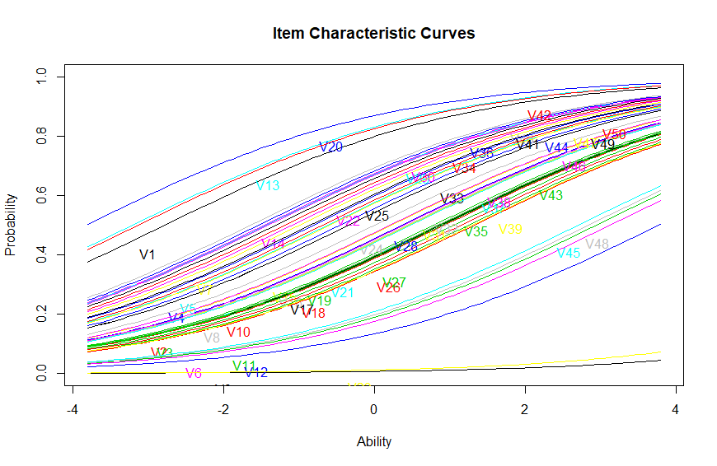
#generate item responses and logit scores per person; z1 is the person score, se.z1 is the standard error for the score; note items deleted from display
factor.scores(item_weights)

Call:
rasch(data = response_matrix, na.action = NULL)

Scoring Method: Empirical Bayes

Factor-Scores for observed response patterns:
It | V1 | V2 | V3 | V4 | V5 | V6 | … | z1 | se.z1
1 | 0 | 0 | 0 | 0 | 0 | 0 |  | -0.805 | 0.534
2 | 0 | 0 | 0 | 0 | 0 | 0 |  | -1.090 | 0.539
3 | 0 | 0 | 0 | 0 | 0 | 0 |  | -0.805 | 0.534
4 | 0 | 0 | 0 | 0 | 0 | 0 |  | -1.090 | 0.539
5 | 0 | 0 | 0 | 0 | 0 | 0 |  | -1.090 | 0.539

2 parameter IRT
(data file, items only scored 0,1)
> MTcsv_noID <- read.csv("H:/00 All PUBS/Assessment/work/2017 Brown & Abdulnabi MCQ in HE/current data/MTcsv_noID.txt", header=FALSE)
> View(MTcsv_noID)

## invoke ltm package in R
library(ltm)

## Descriptive information for XXXX data where XXXX=data file name
dsc <- descript(XXXX, 3)
dsc
Descriptive statistics for the 'MTcsv_noID' data-set
Sample:
50 items and 375 sample units; 0 missing values

Proportions for each level of response:
0 1 logit
V1 0.2133 0.7867 1.3049
V2 0.6080 0.3920 -0.4389
V3 0.6213 0.3787 -0.4952
…
Point Biserial correlation with Total Score:
Included Excluded
V1 0.0128 -0.0560
V2 0.5360 0.4736
V3 0.3222 0.2464
….
Cronbach's alpha:
value
All Items 0.7123
Excluding V1 0.7183
Excluding V2 0.6928
Excluding V3 0.7049
….

##to create a matrix that won’t change order from the data set
response_matrix = (XXXX)

## run the 2PL analysis on the data set; Note na.action=null means ignore any item responses coded na for missing values
item_weights <- ltm(response_matrix ~ z1, na.action = NULL)

##to create 2PL parameters and test-taker location scores calculate the values for each; note: "resp.patterns = response_matrix" binds the ordering of the students and ensures they're not sorted.
locations <- factor.scores(item_weights, resp.patterns = response_matrix)

##to display the discrimination coefficients (a parameter) for each item (nb negative bad):
item_weights[1]$coefficients[,2]
V1 | V2 | V3 | V4 | V5
0.3618220 | -6.6244443 | -0.9466713 | 1.1649277 | 1.1900982

## to display the Item weights or locations (b parameter):
item_weights[1]$coefficients[,1] / item_weights[1]$coefficients[,2] * -1

V1 | V2 | V3 | V4 | V5
-3.158484689 | 0.124698553 | -0.096567721 | 0.275685030 | 0.199588221

## to get student locations on theta (negative means weak, positive means strong); these values now match the order of cases as input.
locations$score.dat["z1"]
z1
1 0.2104774892
2 0.0252190294
3 -0.0443625504
4 -0.0948245513
5 0.1039349259
6 0.0352090683
7 0.0457723256
8 0.0720680887
9 0.0149202265

## To display all parameters at once and get fit indices
> summary(item_weights)

Call:
ltm(formula = response_matrix ~ z1, na.action = NULL)

Model Summary:
log.Lik AIC BIC
-8726.661 17653.32 18046.01

Coefficients:
value std.err z.vals
Dffclt.V1 -3.1585 1.2184 -2.5923
Dffclt.V2 0.1247 0.0391 3.1927
Dffclt.V3 -0.0966 0.1272 -0.7594
…
Dscrmn.V1 0.3618 0.1510 2.3957
Dscrmn.V2 -6.6244 1.0467 -6.3286
Dscrmn.V3 -0.9467 0.1571 -6.0241
….

##Draw ICC for XXXX
plot(item_weights)
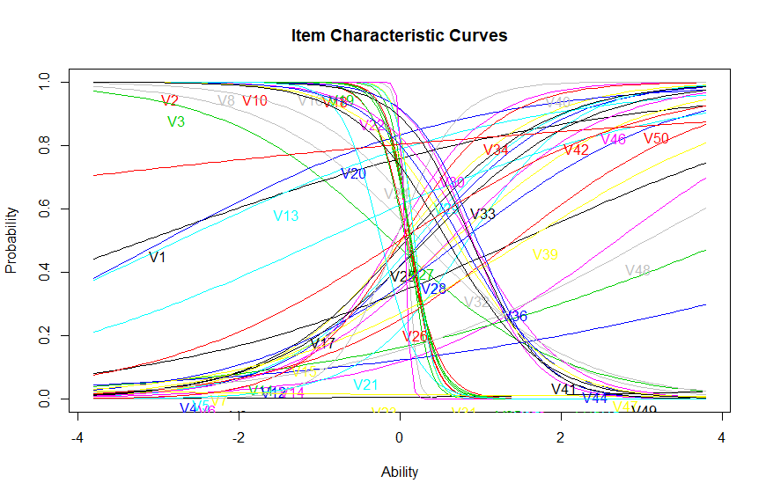

Model selection
Compare AIC values. Smaller is better
To calculate relative merit of models using AIC:
(1) find difference to AIC Min;
(2) calculate exponent of (-0.5*difference);
(3) Sum all weights;
(4) determine proportion of sum for each model.

Models | AIC | Δi (diff AIC minus Min) | Weight AIC (exponent) | wi (proportion of weight) | Sum of wi
Minimum AIC (2PL) | 17653.3 | 0.00 | 1.00 | 1.0000 | 1.00
Comparison AIC (Rasch) | 22582.3 | 4928.98 | 0.00 | 0.0000 | 1.00
sum weights |  |  | 1.00

Interpretation
1. As a rule of thumb, a ∆ i < 2 suggests substantial evidence for the comparison model, values between 3 and 7 indicate that the comparison model has considerably less support, whereas a ∆ i > 10 indicates that the comparison model is very unlikely (Burnham and Anderson 2002).
2. Based on the Akaike weights (wi). To obtain a 95% conﬁdence set on the actual K-L best model, summing the Akaike weights from largest to smallest until that sum is just ≥ models is the conﬁdence set on the K-L best model.0.95, and the corresponding subset of

Procedure taken from: http://avesbiodiv.mncn.csic.es/estadistica/ejemploaic.pdf
Interpretation taken from: http://www4.ncsu.edu/~shu3/Presentation/AIC.pdf

